Carbohydrates: Carbohydrates are macronutrients and are one of the three main ways by which our body obtains its energy. They are called carbohydrates as they comprise carbon, hydrogen and oxygen at their chemical level. Carbohydrates are essential nutrients which include sugars, fibres and starches. They are found in grains, vegetables, fruits and in milk and other dairy products. They are the basic food groups which play an important role in a healthy life.
The food containing carbohydrates are converted into glucose or blood sugar during the process of digestion by the digestive system.
Our body utilizes this sugar as a source of energy for the cells, organs and tissues
Structure and Biological importance of:
Monosaccharides: Monosaccharides , also called simple sugars, are the simplest form of sugar and the most basic units (monomers) of carbohydrates. The general formula is C
[Cn (H2O)n ] or { CH2O}n albeit not all molecules fitting this formula (e.g. acetic acid) are carbohydrates. They are usually colour less, water-soluble, and crystalline solids. Contrary to their name (sugars), only some monosaccharides have a sweet taste.
Examples of monosaccharides include glucose (dextrose), fructose (levulose), and galactose
Xylose ‘ ,ribose , mannose.

Monosaccharides are the building blocks of disaccharides (such as sucrose and lactose) and polysaccharides (such as cellulose and starch). Each carbon atom that supports a hydroxyl group is chiral, except those at the end of the chain. This gives rise to a number of isomeric forms, all with the same chemical formula. For instance, galactose and glucose are both aldohexoses, but have different physical structures and chemical properties.
The monosaccharide glucose plays important role in metabolism, where the chemical energy is extracted through glycolysis and the citric acid cycle to provide energy to living organisms. Some other monosaccharides can be converted in the living organism to glucose.

Glucose:
All monosaccharides have the same general formula of (CH₂O) _{n}, which designates a central carbon molecule bonded to two hydrogens and one oxygen. The oxygen will also bond to a hydrogen, creating a hydroxyl group. Because carbon can form 4 bonds, several of these carbon molecules can bond together. One of the carbons in the chain will form a double bond with an oxygen, which is called a carbonyl group. If this carbonyl occurs at the end of the chain, the monosaccharide is in the aldose family. If the carboxyl group is in the middle of the chain, the monosaccharide is in the ketose family.
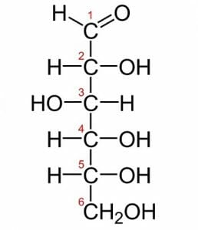
Above is a picture of glucose. Glucose is one of the most common monosaccharides in nature, used by nearly every form of life. This simple monosaccharide is composed of 6 carbons, each labelled in the image. The first carbon is the carbonyl group. Because it is at the end of the molecule, glucose is in the aldose family. Typically, monosaccharides with more than 5 carbons exist as rings in solutions of water. The hydroxyl group on the fifth carbon will react with the first carbon. The hydroxyl group gives up its hydrogen atom when it forms a bond with the first carbon. The double bonded oxygen on the first carbon bonds with a new hydrogen when the second bond with the carbon is broken. This forms a fully connected and stable ring of carbons.
Fructose:
Although almost identical to glucose, fructose is a slightly different molecule. The formula ((CH₂O)₆) is the same, but the structure is much different. Below is an image of fructose:
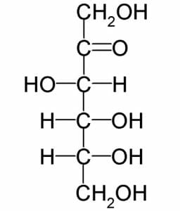fig: Fructose
Notice that instead of the carbonyl group being at the end of the molecule, as in glucose, it is the second carbon down. This makes fructose a ketose, instead of an aldose. Like glucose, fructose still has 6 carbons, each with a hydroxyl group attached. However, because the double bonded oxygen in fructose exists in a different place, a slightly different shaped ring is formed. In nature, this makes a big difference in how the sugar is processed. Most reactions in cells are catalysed by specific enzymes. Different shaped monosaccharides each need a specific enzyme to be broken down.
Fructose, because it is a monosaccharide, can be combined with other monosaccharides to form oligosaccharides. A very common disaccharide made by plants is sucrose. Sucrose is one fructose molecule connected to a glucose molecule through a glycosidic bond.
Galactose:
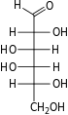

Galactose is a monosaccharide produced in many organisms, especially mammals. Mammals use galactose in milk, to give energy to their offspring. Galactose is combined with glucose to form the disaccharide lactose. The bonds in lactose hold a lot of energy, and special enzymes are created by new born mammals to break these bonds apart. Once being weaned of their mother’s milk, the enzymes that break lactose down into glucose and galactose monosaccharides are lost.
Humans, being the only mammal species that consumes milk in adulthood, has developed some interesting enzyme functions. In populations that drink a lot of milk, most adults are able to digest lactose most of their lives. In populations that do not drink milk after being weaned, lactose-intolerance afflicts nearly the whole population. Although the monosaccharides could be broken down individually, the molecule lactose can no longer be digested. The symptoms of lactose-intolerance (abdominal cramps and diarrhoea) are caused by toxins produced by bacteria in the gut digesting the excess lactose. The toxins and excess nutrients they create raised the total amount of solutes in the intestines, making them retain more water to keep a stable p H.
Ring structure of Glucose, Fructose and Galactose:
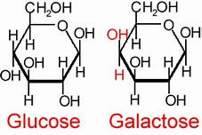

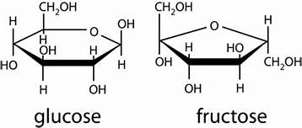
Glucose has the molecular formula (C₆H₁₂O₆) and has a six membered ring. Glucose may be represented by the following open chain structure. But in solution it exists only as a six membered ring structure called pyranose form. Glucose is known as grape sugar.
Fructose has the molecular formula (C₆H₁₂O₆) and has a five membered ring. Fructose exists mostly as a five membered ring structure called “furanose form”. Fructose is known as the fruit sugar as its make source in the diet is fruits and vegetables. Honey is also a good source.

Fructose is more soluble than other sugars and hard to crystallize because it is more hygroscopic and holds onto water stronger than the others. This means that fructose can be used to extend the shelf life of baked products more than other sugars.
Galactose is a monosaccharide and has the same chemical formula as glucose, i.e., C₆H₁₂O₆. It is similar to glucose in its structure, differing only in the position of one hydroxyl group. This difference, however, gives galactose different chemical and biochemical properties to glucose. In solution, it forms 5- and 6-membered rings but also exists in linear form. Small amounts of lactose and galactose can appear in non dairy foods.
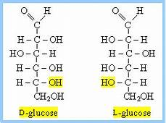
- Dextro or Levo isomers are formed due to the spatial arrangement of bonds in the compound. The significance is that the polarimeter would read a positive angle of rotation for dextro isomers and a negative angle of rotation for Levo isomers.

If the OH in the highest-numbered chiral carbon (closest to the bottom) is on the right we have a D-sugar. If the OH is on the left we have an L-sugar.
Biological importance
Monosaccharides include glucose, fructose, galactose, ribose, xylose, and mannose. The two main functions of monosaccharides in the body are energy storage and as the building blocks of more complex sugars that are used as structural elements.
After breaking down throughout the digestive system, monosaccharides are absorbed into the bloodstream. As carbohydrates are consumed, the blood sugar levels increase, stimulating the pancreas to secrete insulin. Insulin signals the body's cells to absorb the glucose for energy or storage.

Disaccharides:
A disaccharide, also called a double sugar, is a molecule formed by two monosaccharides, or simple sugars. Three common disaccharides are sucrose, maltose, and lactose. They have 12 carbon atoms, and their chemical formula is C₁₂H₂₂O₁₁. Other, less common disaccharides include lactulose, trehalose, and cellobiose. Disaccharides are formed through dehydration reactions in which a total of one water molecule is removed from the two monosaccharides.
The joining of monosaccharides into a double sugar happens by a condensation reaction, which involves the elimination of a water molecule from the functional groups only. Breaking apart a double sugar into its two monosaccharides is accomplished by hydrolysis with the help of a type of enzyme called a disaccharidase. As building the larger sugar ejects a water molecule, breaking it down consumes a water molecule. These reactions are vital in metabolism. Each disaccharide is broken down with the help of a corresponding disaccharidase (sucrase, lactase, and maltase).
The glycosidic bond can be formed between any hydroxy group on the component monosaccharide. Depending on the monosaccharide constituents, disaccharides are sometimes crystalline, sometimes water-soluble, and sometimes sweet-tasting and sticky-feeling. Disaccharides can serve as functional groups by forming glycosidic bonds with other organic compounds, forming biosides.

Sucrose
Sucrose is made up of one molecule of glucose and one molecule of fructose joined together. It is a disaccharide, a molecule composed of two monosaccharides: glucose and fructose. Sucrose is produced naturally in plants, from which table sugar is refined. It has the molecular formula C₁₂H₂₂O₁₁.
For human consumption, sucrose is extracted and refined from either sugarcane or sugar beet. Sugar mills – typically located in tropical regions near where sugarcane is grown – crush the cane and produce raw sugar which is shipped to other factories for refining into pure sucrose. Sugar beet factories are located in temperate climates where the beet is grown, and process the beets directly into refined sugar. The sugar refining process involves washing the raw sugar crystals before dissolving them into a sugar syrup which is filtered and then passed over carbon to remove any residual colour. The sugar syrup is then concentrated by boiling under a vacuum and crystallized as the final purification process to produce crystals of pure sucrose that are clear, odorless, and sweet.

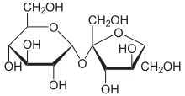
Fig: sucrose

Sucrose Structure
As mentioned above, sucrose is disaccharide, or a molecule made of two monosaccharides. Glucose and fructose are both monosaccharides, but together they make the disaccharide sucrose. This is an important process for the storage and compression of energy. Plants do this to make it easier to transport large amounts of energy, via sucrose. This process can be seen in the following image.
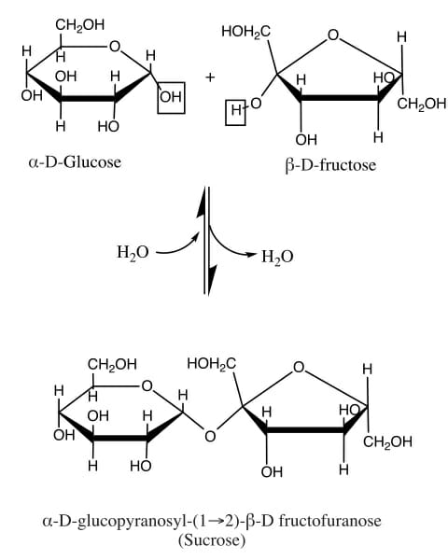
Fig Sucrose condensation
Glucose is seen on the left. Glucose is known as an aldose, meaning the carbonyl group (carbon double bonded to an oxygen) is found at the end of the chain of carbons. When the molecule creates a ring back on itself, it forms a 6-sided ring. Fructose, on the other hand, is a ketose. This means that the carbonyl group is found in the middle of the middle of the molecule. In this case, it forces fructose into a five-sided ring.
In a plant creating sucrose, an enzyme comes along to smash these two rings together, and extract a molecule of water. This process is called a condensation reaction, and forms a glycosidic bond between the two molecules. As you can see in the image, the reaction can also go the other way. To dissolve sucrose into fructose and glucose, a molecule of water can be added back in. This is what happens to sucrose as you digest it.
Maltose: Structure
Maltose which is also known as malt is a disaccharide made up of two alpha D glucose unit. The two-unit of glucose are linked with an alpha 1,4 glycosidic bond. In the small intestinal lining in humans, the enzyme maltase and iso maltose break down the molecules of maltose into two glucose molecules, which are then absorbed by the body. Starch is the most abundant polysaccharide in plant cells after cellulose.
Meanwhile, a carbohydrate formed by joining of two units of glucose is called a disaccharide. The three common types of disaccharides are sucrose, maltose and lactose. The other disaccharides which are less commonly known are lactulose, trehalose, and cellobiose. When one water molecule is removed by joining of two monosaccharides than a molecule of a disaccharide is formed and the reaction which takes place during this process is known as dehydration reactions.
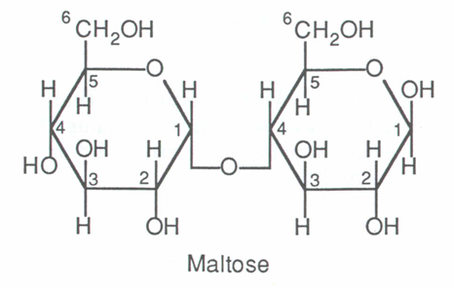
Maltose is a disaccharide made up of two alpha D glucose in which C1 of first glucose unit is bonded to C4 of second glucose unit as shown figure below. The bond that joined two alpha glucose unit is called alpha 1,4 glycosidic linkage.
- Maltose is a reducing sugar. It tastes sweet but is only 30-60% as sweet as sugar.
- The hydrolysis reaction of maltose in the presence of an acid catalyst gives two molecules – alpha D-glucose.

Lactose: Structure
Lactose is a disaccharide derived from the condensation of galactose and glucose, which form a β-1→4 glycosidic linkage. Its systematic name is β-D- galactopyranosyl -(1→4)-D-glucose. The glucose can be in either the α-pyranose form or the β-pyranose form, whereas the galactose can only have the β-pyranose form: hence α-lactose and β-lactose refer to the anomeric form of the glucopyranose ring alone. The different lactose content of different dairy products such as whole milk, lactose free milk, yoghurt, buttermilk, coffee creamer, sour cream, kefir etc.is present.
Lactose is hydrolysed to glucose and galactose, isomerised in alkaline solution to lactulose, and catalytically hydrogenated to the corresponding polyhydric alcohol, lactitol. Lactulose is a commercial product.

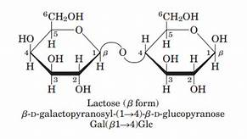

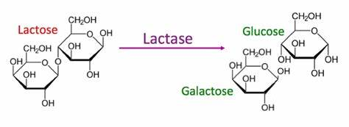
When lactose is completely digested in the small intestine, its caloric value is 4 kcal/g, or the same as that of other carbohydrates. However, lactose is not always fully digested in the small intestine. Depending on ingested dose, combination with meals (either solid or liquid), and lactase activity in the intestines, the caloric value of lactose ranges from 2 to 4 kcal/g. Undigested lactose acts as dietary fibre. It also has positive effects on absorption of minerals, such as calcium and magnesium.
Galactose has various biological functions and serves in neural and immunological processes. Galactose is a component of several macromolecules (cerebrosides, gangliosides and mucoproteins), which are important constituents of nerve cells membrane. Galactose is also a component of the molecules present on blood cells that determine the ABO blood types. According to more recent studies, lactose may play a role in the absorption of calcium and other minerals such as copper and zinc, especially during infancy.
Polysaccharides:
Polysaccharides are major classes of biomolecules. They are long chains of carbohydrate molecules, composed of several smaller monosaccharides. These complex bio-macromolecules functions as an important source of energy in animal cell and form a structural component of a plant cell. It can be a homopolysaccharide or a heteropolysaccharide depending upon the type of the monosaccharides.
Polysaccharides can be a straight chain of monosaccharides known as linear polysaccharides, or it can be branched known as a branched polysaccharide.
Starch, glycogen, and cellulose are examples of polysaccharides.
Polysaccharides have the following properties:
- They are not sweet in taste.
- Many are insoluble in water.
- They are hydrophobic in nature.
- They do not form crystals on desiccation.
Polysaccharides are categorized into two types:
- Homopolysaccharides.
- Heteropolysaccharides.
A polysaccharide that contains the same type of monosaccharides is known as a homopolysaccharide. Some of the important homopolysaccharides are:
- Glycogen: It is made up of a large chain of molecules. It is found in animals and fungi.
- Cellulose: The cell wall of the plants is made up of cellulose. It comprises long chains of ꞵ-glycosides.
- Starch: It is formed by the condensation of amylose and amylopectin. It is found largely in plants, fruits, seeds, etc.
- Inulin: It is made up of a number of fructose furanose molecules linked together in chains. It is found in the tubers of dahlia, artichoke, etc.

Polysaccharides

Polysaccharides

Polysaccharides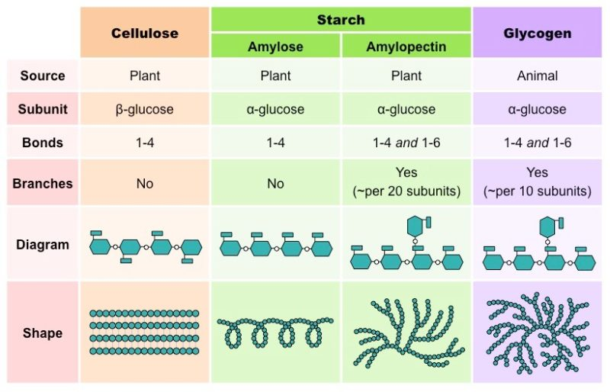

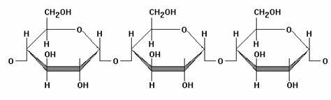

A polysaccharide that contains different types of monosaccharides is known as a heteropolysaccharide. Some of the important heteropolysaccharides are:
- Hyaluronic Acid: It is made up of D-glucuronic acid and N-acetyl-glucosamine. It is found in connective tissues and skin.
- Heparin: It is made up of D-glucuronic acid, L-iduronic acid, N-sulpho-D-glucosamine and is largely distributed in mast cells and blood.
- Chondroitin-4-sulfate: Its component sugars are D-glucuronic acid and N-acetyl-D-galactosamine-4-O-sulfate. It is present in the cartilages.
- Gamma globulin: N-acetyl-hexosamine, D-mannose, D-galactose are the component sugars of this polysaccharide. It is found in the blood.

Hyaluronic acid:

Hyaluronic acid is a polymer of disaccharides, which are composed of D-glucuronic acid and N-acetyl-D-glucosamine, linked via alternating β-(1→4) and β-(1→3) glycosidic bonds. Hyaluronic acid can be 25,000 disaccharide repeats in length.
Hyaluronic acid is energetically stable, in part because of the stereochemistry of its component disaccharides. Hyaluronic acid is synthesized by a class of integral membrane proteins called hyaluronan synthases, of which vertebrates have three types: HAS1, HAS2, and HAS3. These enzymes lengthen hyaluronan by repeatedly adding D-glucuronic acid and N-acetyl-D-glucosamine to the nascent polysaccharide
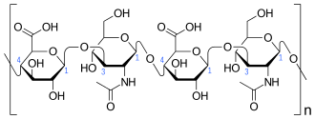
Fig: Hyaluronic acid

Heparin:

Heparin (heparin sodium injectable) is a heterogeneous group of straight-chain anionic mucopolysaccharides, called glycosaminoglycans that have anticoagulant properties used to help prevent clot formation .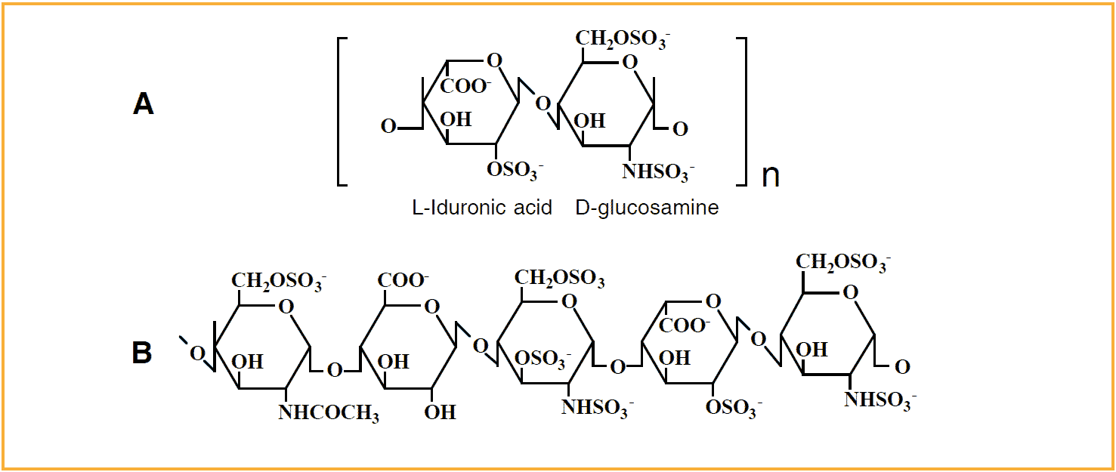Fig: Heparin

Polysaccharides generally perform one of two functions: energy storage or structural support. Starch and glycogen are highly compact polymers that are used for energy storage. Cellulose and chitin are linear polymers that are used for structural support in plants and animals, respectively. Further, multi-cellular organisms have immune systems driven by the recognition of glycoproteins on the surface of cells.

Glycoconjugates:
Many polysaccharides become glycoconjugates when they become covalently bonded to proteins or lipids. Glycolipids and glycoproteins can be used to send signals between and within cells.
They are carbohydrates that are covalently linked to another biomolecule via glycosylation and the carbohydrate constituent of the complex is called a glycan. Glycosylation is a process that forms glycoconjugates. In general, this biochemical process occurs in the cytoplasm of a cell.
Examples of glycoconjugates are glycoproteins, glycopeptides, peptidoglycans, glycosides, glycolipids, and lipopolysaccharides. For instance, a glycolipid is a carbohydrate (e.g. certain oligosaccharides and polysaccharides) attached to a lipid is called a glycolipid. A glycoprotein is a carbohydrate attached to a protein.
Glycoconjugates are involved in cell to cell communications, such as cell-cell recognition. They are also involved in cell to matrix interactions and in the process of detoxification. They are also essential in long term immune protection. Thus, glycoconjugate vaccines (e.g. immunization against influenza) are contrived to boost longer immune protection against carbohydrate antigens.
A glycoprotein pertains to any protein covalently attached to a carbohydrate unit through the process of glycosylation. Some of the common carbohydrate constituents of glycoproteins are β-D-glucose, β-D-galactose, β-D-mannose, α-L-fucose, N-acetylglucosamine, N-acetylgalactosamine, N-acetylneuraminic acid, and xylose. The carbohydrate constituent is attached to the protein via the -OH group of serine or threonine . Some of the examples where glycoproteins are found naturally:
collagen
mucin
immunoglobulin
Glycolipids are lipids with a carbohydrate attached by a glycosidic (covalent) bond. Their role is to maintain the stability of the cell membrane and to facilitate cellular recognition, which is crucial to the immune response and in the connections that allow cells to connect to one another to form tissues.
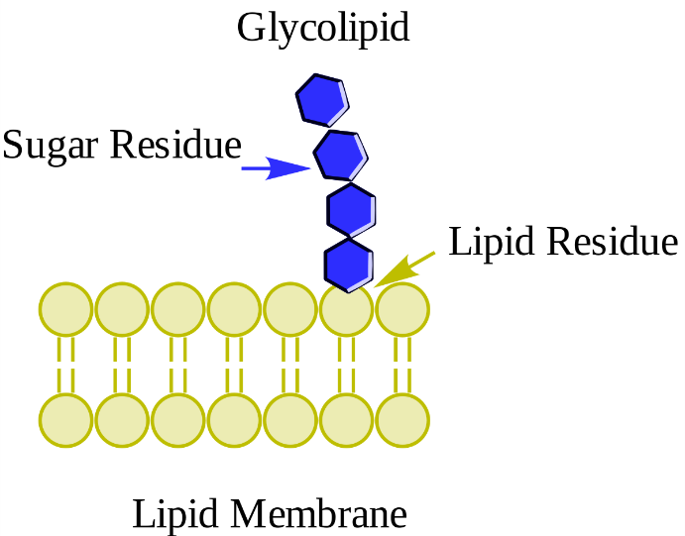

A glycolipid is a carbohydrate that is covalently linked to a lipid. Glycolipids are biomolecular structures in the phospholipid bilayer of the cell membrane whose carbohydrate component extends to the outside of the cell.
Glycolipids are essential in providing stability of the plasma membrane. Furthermore, they are also associated with cell to cell interactions, e.g. cell adhesion to form a tissue. They also facilitate cellular recognition, which is important in immunologic functions.
An example of a glycolipid is a glycosphingolipid. It is comprised of a carbohydrate and a sphingolipid linked together by a glycosidic bond. Hydrolysis of the glycosphingolipid, thus, yields sugar, fatty acid, and sphingosine . The glycosphingolipids are part of the cell membrane and are involved in cell-cell interactions.
Another example of glycolipid is a glycero glycolipid. It is comprised of a glycerol backbone and at least one fatty acid. It includes the galactolipids and sulfo lipids.

Polysaccharides

Polysaccharides

Polysaccharides

Polysaccharides

Polysaccharides

Polysaccharides

Polysaccharides

Polysaccharides

Polysaccharides

Polysaccharides

Polysaccharides

Polysaccharides

Polysaccharides

Polysaccharides

Polysaccharides

Polysaccharides

Polysaccharides

Polysaccharides

Polysaccharides

Polysaccharides

Polysaccharides

Polysaccharides

Polysaccharides

Polysaccharides

Polysaccharides

Polysaccharides

Polysaccharides

Polysaccharides

Polysaccharides

Polysaccharides

Polysaccharides

Polysaccharides

Polysaccharides

Polysaccharides

Polysaccharides

Polysaccharides

Polysaccharides

Polysaccharides

Polysaccharides

Polysaccharides

Polysaccharides

Polysaccharides

Polysaccharides

Polysaccharides

Polysaccharides

Polysaccharides

Polysaccharides

Polysaccharides

Polysaccharides

Polysaccharides

Polysaccharides

Polysaccharides

Polysaccharides

Polysaccharides

Polysaccharides

Polysaccharides

Polysaccharides

Polysaccharides

Polysaccharides

Polysaccharides

Polysaccharides

Polysaccharides

Polysaccharides

Polysaccharides

Polysaccharides

Polysaccharides

Polysaccharides

Polysaccharides

Polysaccharides

Polysaccharides

Polysaccharides

Polysaccharides

Polysaccharides

Polysaccharides

Polysaccharides

Polysaccharides

Polysaccharides

Polysaccharides

Polysaccharides

Polysaccharides

