  - Cell Signaling:

GPCR and Role of Second messenger:

G protein.

G proteins, also known as guanine nucleotide-binding proteins, are a family of proteins that act as molecular switches inside cells, and are involved in transmitting signals from a variety of stimuli outside a cell to its interior. Their activity is regulated by factors that control their ability to bind to and hydrolyze guanosine triphosphate (GTP) to guanosine diphosphate (GDP). When they are bound to GTP, they are 'on', and, when they are bound to GDP, they are 'off'. G proteins belong to the larger group of enzymes called GTPases.
There are two classes of G proteins. The first function as monomeric small GTPases (small G-proteins), while the second function as heterotrimeric G protein complexes. The latter class of complexes is made up of alpha (α), beta (β) and gamma (γ) subunits. In addition, the beta and gamma subunits can form a stable dimeric complex referred to as the beta-gamma complex .
Heterotrimeric G proteins located within the cell are activated by G protein-coupled receptors (GPCRs) that span the cell membrane. Signal molecules bind to a domain of the GPCR located outside the cell, and an intracellular GPCR domain then in turn activates a particular G protein. Some active-state GPCRs have also been shown to be "pre-coupled" with G proteins. The G protein activates a cascade of further signal events that finally results in a change in cell function. G protein-coupled receptor and G proteins working together transmit signals from many hormones, neurotransmitters, and other signal factors. G proteins regulate metabolic enzymes, ion channels, transporter proteins, and other parts of the cell machinery, controlling transcription, motility, contractility, and secretion, which in turn regulate diverse systemic functions such as embryonic development, learning and memory, and homeostasis.

GPCRs

G protein-coupled receptors (GPCRs), also known as seven-(pass)-transmembrane domain receptors, 7TM receptors, hepta helical receptors, serpentine receptors, and G protein-linked receptors (GPLR), form a large group of evolutionarily-related proteins that are cell surface receptors that detect molecules outside the cell and activate cellular responses. Coupling with G proteins, they are called seven-transmembrane receptors because they pass through the cell membrane seven times.
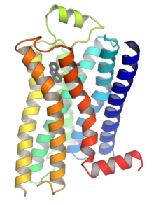
Fig:GPCR

G protein-coupled receptors are found only in eukaryotes, including yeast, choanoflagellates,^{[3]} and animals. The ligands that bind and activate these receptors include light-sensitive compounds, odors, pheromones, hormones, and neurotransmitters, and vary in size from small molecules to peptides to large proteins. G protein-coupled receptors are involved in many diseases.
There are two principal signal transduction pathways involving the G protein-coupled receptors:
- the cAMP signal pathway and
- the phosphatidylinositol signal pathway.
The G protein-coupled receptor is activated by an external signal in the form of a ligand or other signal mediator. This creates a conformational change in the receptor, causing activation of a G protein. Further effect depends on the type of G protein. G proteins are subsequently inactivated by GTPase activating proteins, known as RGS proteins.
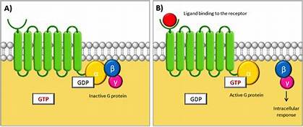
The transduction of the signal through the membrane by the receptor is not completely understood. It is known that in the inactive state, the GPCR is bound to a heterotrimeric G protein complex. Binding of an agonist to the GPCR results in a conformational change in the receptor that is transmitted to the bound G_{α} subunit of the heterotrimeric G protein via protein domain dynamics. The activated G_{α} subunit exchanges GTP in place of GDP which in turn triggers the dissociation of G_{α} subunit from the G_{βγ} dimer and from the receptor. The dissociated G_{α} and G_{βγ} subunits interact with other intracellular proteins to continue the signal transduction cascade while the freed GPCR is able to rebind to another heterotrimeric G protein to form a new complex that is ready to initiate another round of signal transduction.[
It is believed that a receptor molecule exists in a conformational equilibrium between active and inactive biophysical states. The binding of ligands to the receptor may shift the equilibrium toward the active receptor states. Three types of ligands exist: Agonists are ligands that shift the equilibrium in favour of active states; inverse agonists are ligands that shift the equilibrium in favour of inactive states; and neutral antagonists are ligands that do not affect the equilibrium. It is not yet known how exactly the active and inactive states differ from each other.

Signaling
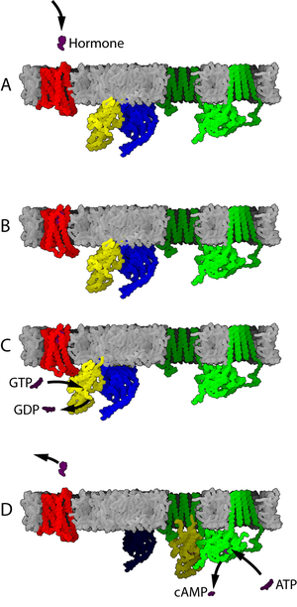
Fig G-protein-coupled receptor mechanism
If a receptor in an active state encounters a G protein, it may activate it. Some evidence suggests that receptors and G proteins are actually pre-coupled. For example, binding of G proteins to receptors affects the receptor's affinity for ligands. Activated G proteins are bound to GTP.
Further signal transduction depends on the type of G protein. The enzyme adenylate cyclase is an example of a cellular protein that can be regulated by a G protein, in this case the G protein G_{s}. Adenylate cyclase activity is activated when it binds to a subunit of the activated G protein. Activation of adenylate cyclase ends when the G protein returns to the GDP-bound state.
Adenylate cyclases (of which 9 membrane-bound and one cytosolic forms are known in humans) may also be activated or inhibited in other ways (e.g., Ca2+/Calmodulin binding), which can modify the activity of these enzymes in an additive or synergistic fashion along with the G proteins.
The signaling pathways activated through a GPCR are limited by the primary sequence and tertiary structure of the GPCR itself but ultimately determined by the particular conformation stabilized by a particular ligand, as well as the availability of transducer molecules. Currently, GPCRs are considered to utilize two primary types of transducers: G-proteins and β-arrestins. Because β-arr’s have high affinity only to the phosphorylated form of most GPCRs (see above or below), the majority of signalling is ultimately dependent upon G-protein activation. However, the possibility for interaction does allow for G-protein-independent signaling to occur.

Role of secondary messenger(cAMP)
Second messenger, molecule inside cells that acts to transmit signals from a receptor to a target. The term second messenger was coined upon the discovery of these substances in order to distinguish them from hormones and other molecules that function outside the cell as “first messengers” in the transmission of biological information. Many second messenger molecules are small and therefore diffuse rapidly through the cytoplasm, enabling information to move quickly throughout the cell. As elements of signaling pathways, second messengers can serve to integrate information when multiple independent upstream inputs influence the rates of synthesis and degradation of the second messenger. In addition, second messengers can have multiple downstream targets, thereby expanding the scope of signal transmission.
A large number of second messenger molecules have been characterized, including cyclic nucleotides (e.g., cyclic adenosine monophosphate, or cAMP, and cyclic guanosine monophosphate, or cGMP), ions (e.g., Ca²⁺), phospholipid-derived molecules (e.g., inositol triphosphate), and even a gas, nitric oxide (NO). The calcium ion Ca²⁺ has a critical role in the rapid responses of neurons and muscle cells. At rest, cells maintain a low concentration of Ca²⁺ in the cytoplasm, expending energy to pump these ions out of the cell. When activated, neurons and muscle cells rapidly increase their cytoplasmic Ca²⁺ concentration by opening channels in the cell membrane, which allow Ca²⁺ ions outside the cell to enter rapidly. The cyclic nucleotide cAMP is synthesized by adenylyl cyclase enzymes, which are downstream of heterotrimeric G-proteins (guanine nucleotide binding proteins) and receptors. For example, when epinephrine binds to beta-adrenergic receptors in cell membranes, G-protein activation stimulates cAMP synthesis by adenylyl cyclase. The newly synthesized cAMP is then able to act as a second messenger, rapidly propagating the epinephrine signal to the appropriate molecules in the cell. This stimulatory signaling pathway leads to the production of effects such as increasing rate and force of contraction of the heart that are characteristic of epinephrine. Caffeine also enhances the action of cAMP by inhibiting the enzyme phosphodiesterase, which degrades cAMP; the enhancement of cAMP activity contributes to the general stimulatory action of caffeine. As a gas, nitric oxide (NO) is distinct among second messengers in being able to diffuse across cell membranes, which allows signal information to cross into neighbouring cells.
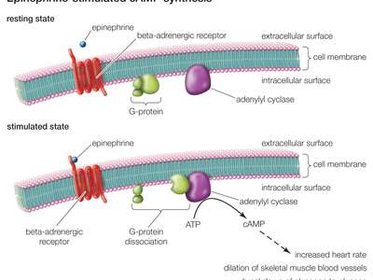
The cAMP signal transduction contains 5 main characters: stimulative hormone receptor (Rs) or inhibitory hormone receptor (Ri); stimulative regulative G-protein (Gs) or inhibitory regulative G-protein (Gi); adenylyl cyclase; protein kinase A (PKA); and cAMP phosphodiesterase.
Stimulative hormone receptor (Rs) is a receptor that can bind with stimulative signal molecules, while inhibitory hormone receptor (Ri) is a receptor that can bind with inhibitory signal molecules.
Stimulative regulative G-protein is a G-protein linked to stimulative hormone receptor (Rs), and its α subunit upon activation could stimulate the activity of an enzyme or other intracellular metabolism. On the contrary, inhibitory regulative G-protein is linked to an inhibitory hormone receptor, and its α subunit upon activation could inhibit the activity of an enzyme or other intracellular metabolism.
Adenylyl cyclase is a 12-transmembrane glycoprotein that catalyse ATP to form cAMP with the help of cofactor Mg²⁺ or Mn²⁺. The cAMP produced is a second messenger in cellular metabolism and is an allosteric activator of protein kinase A.
Protein kinase A is an important enzyme in cell metabolism due to its ability to regulate cell metabolism by phosphorylating specific committed enzymes in the metabolic pathway. It can also regulate specific gene expression, cellular secretion, and membrane permeability. The protein enzyme contains two catalytic subunits and two regulatory subunits. When there is no cAMP the complex is inactive. When cAMP binds to the regulatory subunits, their conformation is altered, causing the dissociation of the regulatory subunits, which activates protein kinase A and allows further biological effects.
These signals then can be terminated by cAMP phosphodiesterase, which is an enzyme that degrades cAMP to 5'-AMP and inactivates protein kinase A.

Physiological roles
GPCRs are involved in a wide variety of physiological processes. Some examples of their physiological roles include:
- The visual sense: The opsins use a photoisomerization reaction to translate electromagnetic radiation into cellular signals. Rhodopsin, for example, uses the conversion of 11-cis-retinal to all-trans-retinal for this purpose.
The gustatory sense (taste): GPCRs in taste cells mediate release of Gustducin in response to bitter-, umami- and sweet-tasting substances.
- The sense of smell: Receptors of the olfactory epithelium bind odorants (olfactory receptors) and pheromones (vomeronasal receptors)
- Behavioural and mood regulation: Receptors in the mammalian brain bind several different neurotransmitters, including serotonin, dopamine, histamine, GABA, and glutamate
- Regulation of immune system activity and inflammation: chemokine receptors bind ligands that mediate intercellular communication between cells of the immune system; receptors such as histamine receptors bind inflammatory mediators and engage target cell types in the inflammatory response. GPCRs are also involved in immune-modulation, e. g. regulating interleukin induction or suppressing TLR-induced immune responses from T cells.
- Autonomic nervous system transmission: Both the sympathetic and parasympathetic nervous systems are regulated by GPCR pathways, responsible for control of many automatic functions of the body such as blood pressure, heart rate, and digestive processes
- Cell density sensing: A novel GPCR role in regulating cell density sensing.
- Homeostasis modulation (e.g., water balance).
- Involved in growth and metastasis of some types of tumours.
- Used in the endocrine system for peptide and amino-acid derivative hormones that bind to GCPRs on the cell membrane of a target cell. This activates cAMP, which in turn activates several kinases, allowing for a cellular response, such as transcription.

