Meiosis cell division:
Meiosis is a special type of cell division of germ cells in sexually-reproducing organisms used to produce the gametes, such as sperm or egg cells. It involves two rounds of division that ultimately result in four cells with only one copy of each chromosome (haploid). Additionally, prior to the division, genetic material from the paternal and maternal copies of each chromosome is crossed over, creating new combinations of code on each chromosome.^{[3]} Later on, during fertilisation, the haploid cells produced by meiosis from a male and female will fuse to create a cell with two copies of each chromosome again, the zygote.
Meiosis cell division has two rounds of cell division to produce four daughter cells, each with half the number of chromosomes as the original parent cell. The two meiotic divisions are known as meiosis I and meiosis II.
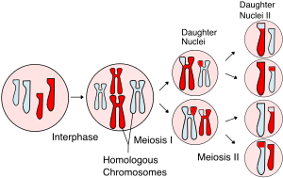
Fig: Meiosis cell division

The salient features of meiotic division that make it different from mitosis are as follows:-
- It occurs in two stages of the nuclear and cellular division as Meiosis I and Meiosis II. DNA replication occurs, however, only once.
- It involves the pairing of homologous chromosomes and recombination between them.
- Four haploid daughter cells are produced at the end, unlike two diploid daughter cells in mitosis.
Meiosis I Reductional division:
Stages of meiosis I division:
The different stages of meiosis 1 can be explained by the following phases :
- Prophase 1
- Metaphase 1
- Anaphase 1
- Telophase I
- Cytokinesis I

Interphase
- Just like mitosis, meiosis also consists of a preparatory phase called interphase.
- The interphase is characterized by the following features :
- The nuclear envelope remains intact, and the chromosomes occur in the form of diffused, long, coiled, and indistinctly visible chromatin fibres.
- The DNA amount becomes double. Due to the accumulation of ribosomal RNA (rRNA) and ribosomal proteins in the nucleolus, the size of the nucleolus is significantly increased.
- In animal cells, a daughter pair of centrioles originates near the already existing centriole and, thus, an interphase cell has two pairs of centrioles.
- In the G₂ phase of interphase, there is a decisive change that directs the cell toward meiosis, instead of mitosis.
- At the beginning of the first meiotic division, the nucleus of the dividing cell starts to increase in size by absorbing the water from the cytoplasm, and the nuclear volume increases about three folds.

Prophase I
Prophase I is the longest stage of the meiotic division. It includes the following substages:
  - leptotene
  - zygotene
  - pachytene
  - diplotene
  - diakinesis
- 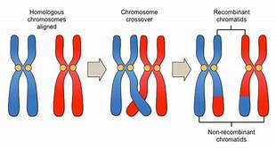
Fig: Crossing over between the homologous pairs of chromosomes.
Leptotene
- In the leptotene stage, the chromosomes become even more uncoiled and resemble a long thread-like shape, and they develop bead-like structures called chromomeres.
- The chromosomes at this stage remain directed towards centrioles, so the chromosomes in the nucleus appear like a bouquet in the animal cell. Therefore, this stage is also called the Bouquet Stage.
Zygotene
- The zygotene stage begins with the pairing of homologous chromosomes, which is called synapsis.
- The paired homologous chromosomes are connected by a protein-containing framework called a synaptonemal complex.
- The synaptonemal complex helps to stabilize the pairing of homologous chromosomes and to facilitate recombination or crossing over.
- The synapsis might begin at one or more points along the length of the homologous chromosomes.
- Synapsis might start from the ends of the chromosomes and continues towards their centromeres (pro terminal synapsis), or it might start at the centromere and proceed towards the ends (pro centric pairing).
- In some cases, the synapsis occurs at various points of the homologous chromosomes (random pairing).

Pachytene
- In this stage, the pair of chromosomes become twisted spirally around each other and cannot be distinguished separately.
- In the middle of the pachytene stage, each homologous chromosome splits lengthwise to form two chromatids, but they continue to be linked together by their common centromere.
- The chromosomes at this point are termed bivalent because it consists of two visible chromosomes, or as a tetrad because of the four visible chromatids.
- This stage is particularly crucial as a critical genetic phenomenon called ‘crossing over’ takes place in this stage.
- The crossing over involves redistribution and mutual exchange of hereditary material between two homologous chromosomes.
- The enzyme endonuclease breaks the non-sister chromatids at the place of crossing over.
- After the breaking of chromatids, the interchange of chromatid segments takes place between the non-sister chromatids of the homologous chromosomes.
- Another enzyme, ligase, binds the broken chromatid segments with the non-sister chromatid.
- The process of mutual exchange of chromatin material between one non-sister chromatid of each homologous chromosome is known as the crossing over.
Diplotene
- The synaptonemal complex appears to be dissolved, leaving chromatids of the paired homologous chromosome physically joined at one or more localized points called
- In diplotene, chiasmata move towards the end of chromosomes in a zip like a manner.
Diakinesis
- In this stage, the bivalent chromosomes become more condensed and uniformly distributed in the nucleus.
- At this point, the nuclear envelope breaks down, and the nucleolus disappears.
- Further, the chiasmata reach the end of the chromosomes, and the chromatids remain attached until metaphase.

Metaphase I
- Metaphase I consists of spindle fibre attachment to chromosomes and chromosomal alignment at the equator.
- During metaphase I, the spindle fibres are attached with the centromeres of the homologous chromosomes, which are directed towards the opposite poles.

Anaphase I
- At anaphase I homologous chromosomes are separated from each other, and due to the shortening of chromosomal fibres or microtubules, each homologous chromosome with its two chromatids and undivided centromere move towards the opposite poles of the cell.
- Because during the chiasma formation, one of the chromatids has changed its counterpart, therefore, the two chromatids of a chromosome are not genetically identical.

Telophase I
- The onset of telophase I is defined by the movement of a haploid set of chromosomes at each pole.
- The nuclear envelope is formed around the chromosomes, and the chromosomes become uncoiled. The nucleolus reappears and, thus, two daughter nuclei are formed.

Cytokinesis I
- In animals, cytokinesis occurs by the constriction of the cell membrane while in plants, it occurs through the formation of the cell plate, resulting in the creation of two daughter cells.
- 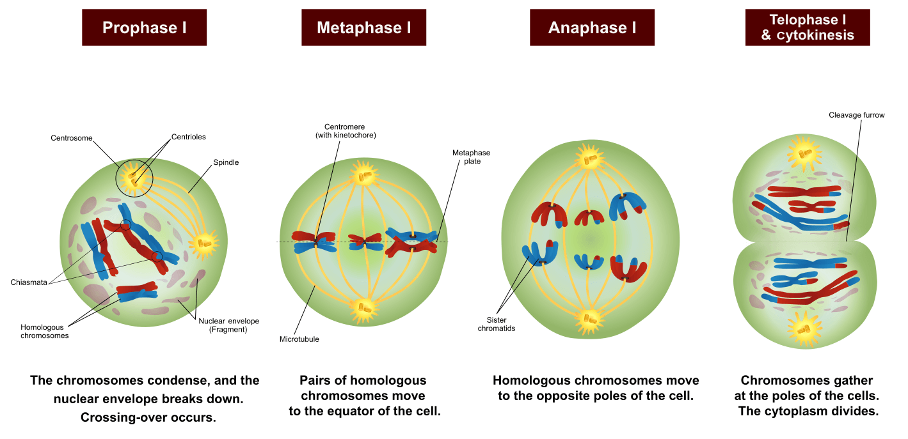
Fig: Meiosis I division.

Meiosis II Equational division:

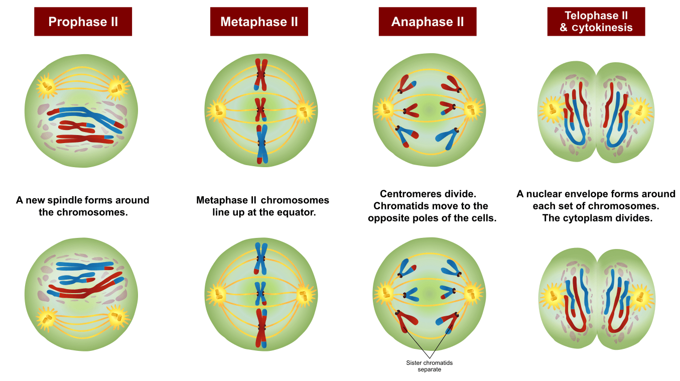Figure: Phases of Meiosis II.
- In the second phase of the meiotic division, the haploid cell divides mitotically and results in four haploid cells. This division is also known as the homotypic division.
- This division does not include the exchange of the genetic material and the reduction of the chromosome number as in the first meiotic division.
- Meiosis II consists of the following steps:

Prophase II
- In prophase II, each centriole divides, resulting in two pairs of centrioles.
- The centrioles move towards the opposite poles and the nuclear membrane, and the nucleolus disappears.

Metaphase II
- During metaphase II, the chromosomes get arranged on the equator of the cell through the spindle fibres.
- The centromere divides and, thus, each chromosome produces two daughter chromosomes.
- The spindle apparatus is attached to the centromere of each chromosome.

Anaphase II
- The daughter chromosomes move towards the opposite poles due to the shortening of chromosomal microtubules and the stretching of interzonal microtubules of the spindle.

Telophase II
- The chromatids migrate to the opposite poles and now known as chromosomes.
- The endoplasmic reticulum forms the nuclear envelope around the chromosomes, and the nucleolus reappears due to the synthesis of ribosomal RNA.

Cytokinesis II
- The process of cytokinesis is identical to cytokinesis I resulting in the division of cytoplasm for each of the four daughter cells formed.

Significances of meiosis division:
1. Meiosis form gametes that are required for sexual reproduction
2. Meiosis maintains the fixed number of chromosomes in sexually reproducing organisms by having the same during gametogenesis
3. In meiosis, paternal and maternal chromosomes assort independently. It causes a reshuffling of chromosomes and the traits controlled by them. The variations help the breeders in improving the races of useful plants and animals.
4. Meiosis introduces a new combination of traits or variations.
5. Chromosomal and genomic mutations occur by irregularities of meiotic division. Some of these mutations are useful to the organism.

