Lac culture:
Humans have been enjoying animals for their varied uses. Not only domestic animals but wild animals are useful to us in many ways. Animals of all sizes and types are useful to humans in many ways. The list of products that we get from live as well as dead animals is probably never-ending. One such fascinating and tiny insect is the lac insect, and it gives us a product used in different ways. Today we are looking at the insect, its culture and why it is useful to us.
Lac is a natural resinous material secreted by insects called lac insects. The scientific management and rearing of lac insects for high-quality lac,to be used for commercial purposes are called lac culture. Management of lac culture involves the selection of host plants, inoculation of plants with lac insects, rearing of lac insects, pest management , harvesting and processing of lac.

The Systematic Position of Lac Insect

The lac insect is classified as follows:
Kingdom: Animalia
Phylum: Arthropoda
Class: Insecta
Order Hemiptera
Superfamily — Coccoidea
Family — Kerriidae
Genus — Laccifer
Species — lacca
So, the binomial name of lac insects is Laccifer lacca

Lac insect is an ectoparasite and feeds on the plant sap sucked from the tender shoot of the plant. So, they can be reared on specific trees only, and these trees/plants are called host plants. The lac culturist must know the host plants and which plants suit the geographic conditions of the place. The lac management includes the rearing of healthy host plants in a stage that is suitable for the lac insects to suck the sap.

The host plants of lac insects are:
Vernacular name | Scientific name
Kusum | Schleichera trijuga/oleosa
Palas | Butea frondosa or Butea monosperma
Ber (plum) | Zizyphus jujuba
Babul | Acacia arabica
Khair (Ranjeeni) | Acacia catechu
Arhar | Cajanus indicus

Life Cycle of Lac Insect

A lac culturist must have knowledge of the life cycle of lac insects and must be able to identify the stage at which lac is produced maximum and to be harvested. The lac insects show very distinct morphological differences and sexual dimorphism. The life cycle of lac insect has 4 stages as-
- Eggs
- Larva
- Pupa
- Adult
The phases of the life cycle of lac insect are as follows:
- Fertilization: the male adult walks over the female incrustations and inserts itself into the female cells, where it fertilizes the female.
- Egg-laying: After fertilization, the female grows rapidly till it becomes capable of egg-laying. A single female lays an average of 200 to 500 eggs after fertilization and deposits inside the incubating chambers of the female cell.
- Egg Hatching: After 6 weeks, the eggs are hatched into first instar larvae. The mass movement of these larvae in search of a suitable place to suck plant sap is called swarming.
- Pupa: A larva is a sluggish and continuous feeder. It encases itself and the twig by secreting a resinous secretion from the body. The secretion hardens upon contact with air and is called a lac cell. Inside the lac cell, the larva undergoes three moultings. During moulting, male and females lose some body parts.

Adults: Male larvae develop into male adult insects and are without any mouthparts and thus do not feed. One adult male insect can fertilize several females, and soon after fertilization, it dies. The adult female is smaller in size than the male and is without legs and wings. The female larvae never move out of the cell once they settle down after swarming.

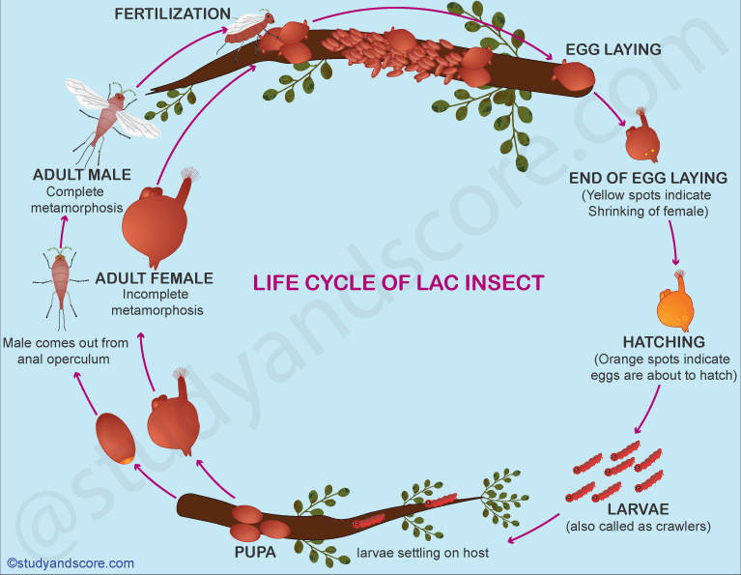

Lac Secretion and Composition
Lac is the only known commercial resin of animal origin. It is a resinous material secreted by the lac insects. Special glands called lac glands are present in the skin of the larvae and the adults. Lac is a mixture of several substances, but resin is the main constituent. It is thought to be a polyester of straight chain of complex fatty acids containing 14 to 18 carbon atoms. The approximate percentage of different constituents of lac is resin 68 to 90%,, dye 2 to 10%,, wax 5 to 6%,, mineral matter 3 to 7%,, albuminous matter 5 to 10% and water 2 to 3%.. It also contains sugar, proteins, soluble salts, debris of lac insect and some woody material.

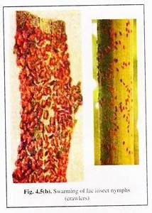
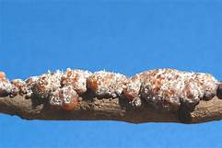

Lac Cultivation

Culturing of lac begins when the farmer inoculates a plant with a female cell where eggs are ready to hatch. As soon as the eggs hatch and first instar larvae emerge, they infest the host plant by a process called swarming. After finding the spots for feeding, the larvae start secreting the resinous material around their body. This material appears shiny in the beginning and hardens when it comes in contact with air. The lac casing is thus around the body of the larva and the twig on which it is feeding. Many lac cells of nearby larvae fuse together, and a lac incrustation is formed. This is the lac that a lac culturist is interested in.
The steps of lac cultivation are:
- Inoculation: inoculation means the introduction of lac insects to the host plant. Inoculation can be natural (without any human intervention) or artificial.
- Cultivation of host plants: since the larvae of lac insects suck the plant sap from the tender shoots of host plants, proper cultivation and pruning become important in lac culture.
- Lac Crop: the life cycle of lac insects of months and hence two crops in a year are regular. There can be four lac crops as lac insects behave differently on Kusum and non-Kusum host plants.
- Harvesting and Extraction of Lac:
a. The twigs with thick encrustations are cut and removed from the site. This is stick lac
b. Then the lac cells are scraped from the twig, and the lac is the granular lac. If the cutting and scraping is done before swarming, it is ‘Ari lac’, and if it is done after swarming, it is ‘Phunki lac’
c. The scraped lac is washed thoroughly with water. Drying and bleaching of lac are done by exposing it to sunlight.
d. Lac granules are melted in a pot over an open charcoal fire.
e. The molten lac is then spread in the form of sheets. The sheets are dried, broken into pieces and sold in the market as flakes.

Depending on the host plant, lac is of two types:
- Kusumi Lac: insects are reared on Kusum plants, and lac is harvested from these plants.
- Ranjeeni Lac: when the lac insects are reared on non-Kusum plants, the lac is known as Ranjeeni lac.

Use of Lac
Lac is used for making toys, bracelets or bangles, for filling the ornament, sealing wax, gramophone records etc. It is also used in making the grinding stones, for manufacturing varnishes and paints, for silvering the back of a mirror, for encasing cable wires (due to insulating property of lac) etc. During the washing of scraped lac, a dye is left behind in the water which is then used for dying purposes. Some examples of by-products of lac are nail polish, lithographic ink, shoe polish etc.

Position of Lac Culture
- Globally lac is produced in many countries like India, Thailand, Myanmar, China, Indonesia, Vietnam and Laos.
- India and Thailand are the major producers, producing an average of 1700 tonnes annually, followed by China.
- Until 1950, India held the monopoly in lac production, accounting for almost 85% of the global production.
- In a later period, Thailand became one of the major competitors.
- Now India’s contribution to global lac production is about 70%..
- Roughly 200 million rupees is the net export of lac from India
- 3−−4 million people, including tribals, are engaged in lac culture in India
- In India, Bihar is the highest producer of lac.
- Other states like Madhya Pradesh, West Bengal, Maharashtra, Assam and Odisha also produce lac.
Some pockets of lac cultivation also exist in Andhra Pradesh, Punjab, Rajasthan, Karnataka, Gujarat, and Mirzapur and Sonebhdra districts of Uttar Pradesh

A lesser-known but economically sustainable part of animal husbandry, lac culture makes a worth-attention topic of applied zoology. A small insect of the order Hemiptera, lac insect, is reared for the resinous material that it secretes during its life cycle. Larva and pupa are the main stages that produce lac. Lac is the only known commercial resin of animal origin.

