Eri silk:
Eri culture is mostly confined to the Brahmaputra valley of Assam. It is also practiced in few district of the neighboring states mainly Arunachal Pradesh, Manipur, Meghalaya, Nagaland and other non traditional states of India like Andhra Pradesh, Bihar, Chhattisgarh, Gujrat, Jharkhand, Orissa, Tamilnadu, Utrakhand, West Bengal,
Eri silkworm is multivoltine in nature. It can rear 4-5 times in a year.
There are 26 eco-races of eri silkworm like Borduar, Khanapara, Kokrajhar, Titabar, Diphu, Genung, Nongpoh etc.
The silk worms of the silk moths Philosamia ricini and Attacus ricini generate a different kind of white silk, called eri silk.
Ericulture is a small scale industry. In fact, eri cocoon is considered as a palatable item to the local people of Assam. Castor, the host plant of eri moth is mainly used in other parts of India for production of seed as a valuable material; but in N.E. region because of its profuse vegetative growth and poor yield of seeds, the leaves are utilised for production of eri cocoon only.

Life cycle of eri silk:

To encourage the eri silk rearing commercially, the Assam Government has established several eri spun plants and research centres to provide necessary materials and suggestion to the rearers.
The eri moth is multivoltine in nature and can pass 6 life cycles in a year. These worms are totally domesticated and are reared indoors.

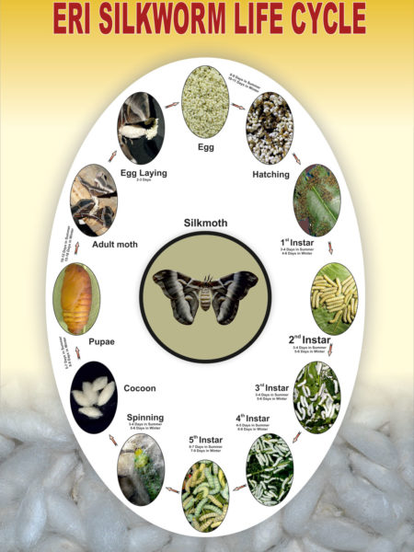

Its life cycle consists of 4 stages as follows.
Adult:
Adult moths are large with wings spanning about 10 cm. The wings are greyish brown in colour with prominent eye spot . When the adult moth emerges from a cocoon it makes a hole to get out. Like other silk moths, eri moths also start mating activities following their emergence from pupal stage.

Egg:
Following mating, the female starts egg laying that may continue up to 3 days. Each female can lay about 350-500 eggs . Hatching depends on prevailing environmental conditions and may occur from 8-20 days.
Larvae:
The hair like newly hatched larvae are yellow in colour . Initially they feed on soft castor leaves but at later stages, worms can feed on mature leaves. After moulting for 4 times by 30- 32 days they spin the cocoon among the leaves.
Caterpillars in their final stages start spinning the cocoons. The spinning is completed in 2-3 days. The cocoons are open mouthed, tapering at one end and flat rounded at the open end. Eri cocoons are stalkless, flossy, white or brick red in colour , 5 cm long in case of female and 4.6 cm long in male.
Pupa:
Pupal stages last for 15-37 days during when larvae change to pupae.

Rearing of eri silkworm:
Disease-free seed cocoons are obtained from grainages or agencies and reared fully indoors. Healthy cocoons are spread on bamboo trays in cool dark room. On hatching, active males are separated from passive females and are then allowed to mate in quiet dark room.
Fertilised females are then tied to ‘kharikas’ by passing a thread around the thoracic joint of the right wings. Kharikas are then suspended from a string. Eggs are laid within 25 hours on Kharika and are normally selected for rearing. The eggs are white, oval and covered with a gummy substance, which makes them adhere to one another.

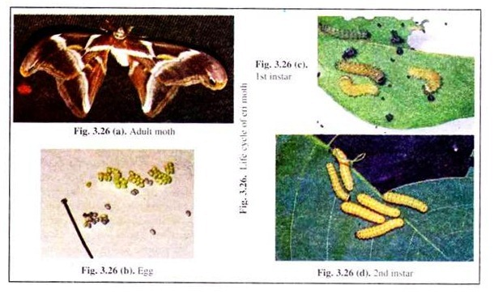

The eggs are disinfected with 2% formalin solution and then washed thoroughly with water. Eggs are incubated at 26°C, the colour changes to blue on the day prior to hatching. Hatching takes place in the morning after ten days of incubation. The newly hatched larvae are yellow with black segments.
These larvae are brushed to rearing trays over which few tender food leaves are spread, and crowding is avoided. As the worms advance in age, older leaves can be given as food at 2-hour interval for four to five times.
Bed cleaning is carried out at regular interval in the same way as for the mulberry silkworm. The growing worms undergo four moults and have five instar stages. Total larval period lasts for 30-35 days. The 5th instar, mature larvae stop feeding and start searching for a proper place to spin the cocoon.

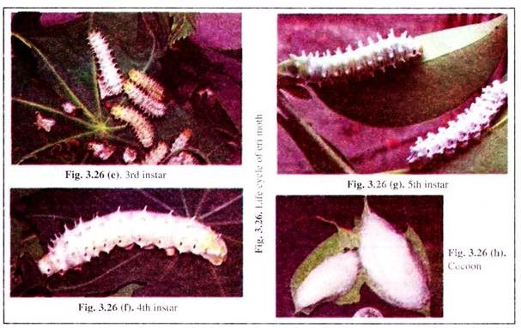
At this stage, the mature worms are picked up and transferred to mountages (Chandri-kas). In wild, cocoons are spun between folds of leaves.
Post cocoon processing:
Stifling is done by spreading and exposing the cocoons to the sun for 1 -2 days. For degumming, cocoons are tied in a cloth sac and dipped in boiling soda solution. After sufficient boiling, the cocoons are taken out washed with water several times to remove soda, squeezed to remove water and then spread on mats to dry.
Being open mouthed, the thread of the cocoons is discontinuous. So, the thread can only be spun and not reeled. Traditionally, spinning is done in wet condition on takli and in semidried condition on a charkha.
Nature of Eri silk:
The silk produced by eri moths is referred to as eri and endi or errandi silk by local people. This silk is collected from pierced cocoons, so it is spun silk. The fibres in the cocoon are like a tiny bale of cotton, all wound together and tangled. So when eri silk is spun, it forms a lower grade of silk of unusual quality.
Depending on how it is spun and woven it can give a very woolly result and as with poorly made wools, eri can feel like cheap acrylic. But it can also give a tight, strong fibre-like linen. This is what makes eri textiles amazing — they can have the drape and weight of linen but are warm and insulating like cotton or wool Eri silk is less glossy and wrinkleless.

