Seri culture: Life Cycle of Muga Silk Worm

Sericulture, or silk farming, is the cultivation of silkworms to produce silk. Although there are several commercial species of silkworms, Bombyx mori (the caterpillar of the domestic silkmoth) is the most widely used and intensively studied silkworm. Silk was believed to have first been produced in China as early as the Neolithic Period. Sericulture has become an important cottage industry in the districts of Assam today .Muga silk is the indigenous varity
of silk of Assam.
. Various silk worms besides Bombyx mori (mulberry silkworm) are Antheraea assamensis (Muga silkworm) Antheraea mylitta (Tussora silkworm). A. pernyl (Oak silkworm). Attacus atlas (eri silkworm).

Muga Silk:

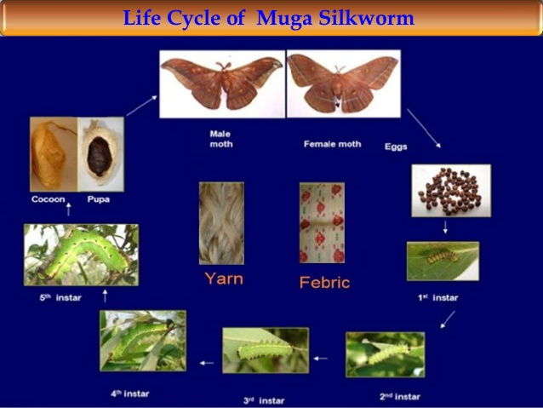
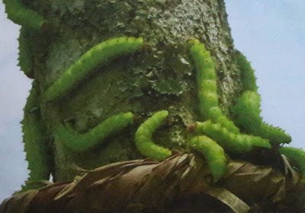

Distribution
- The native place of this moth is Assam.

- Its production was confined to Assam, border areas of neighbouring north-eastern states and Cooch Bihar in West Bengal.

- Now it is reared in Nagaland, Meghalaya and Andhra Pradesh also.

Life history
- The moth is multivoltine the entire life cycle lasts for about 50 days in summer and 120 days in winter.

- This moth is semi-domesticated and can be raised outdoor.

- Muga moth (“Muga Polu’ in Assamese) also has the same life cycle as other silkworms, i.e., egg, larva, pupa and adult.

- The muga worm feeds on aromatic leaves of Som and Soalu

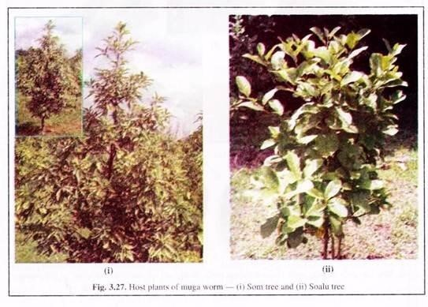
- It can also be reared on host plants similar to that of tasar worms.
:

- Life history:

- The moth is multivoltine the entire life cycle lasts for about 50 days in summer and 120 days in winter. This moth is semi-domesticated and can be raised outdoor. Muga moth (“Muga Polu’ in Assamese) also has the same life cycle as other silkworms, i.e., egg, larva, pupa and adult

- .
- Adult muga moth:

- The wings and body of the male moth are copper brown to dark brown, while those of female is yellowish to brown. Besides colouration, the male moth can be distinguished from the female by its slightly smaller size, slender abdomen, bushy antennae and sharply curved forewing tips.
- Antheraea assamensis can be identified by the orange eye-spots, the pale leading edge of the forewing, and a black spot in the rear wing eye- spot located towards the body . Typically, the males find the females upon emergence and copulate immediately.

- Egg:

- The female moth’s eggs (popularly known as seeds) are laid on the Som and Soalu leaves.

- Larvae
- :
- Eggs are hatched into larvae of about 2 mm long. They grow rapidly, eat voraciously and end up about 30 mm long after 4-5 weeks. During this time, they moult four times. At the end, they search suitable place for cocooning.

- Pupa:
- Within the cocoon the larva pupates.

- Rearing of muga moth:

- The seed cocoons intended for preparation of eggs are obtained from commercial rearers or from Government grainages. These are then laid in a single layer in trays to facilitate the emergence of moths. Emergence starts from dusk and continues till morning.

- The emerging adults are allowed to mate and in the coupled state, the pair is tied with a piece of cotton thread to 1.5-2 feet long stick made of dried straw which is known as Kharika. After overnight mating, the couples separate in the morning and if they do not decouple naturally they are made to do so by heat of fire lighted some distance away. The female moth lays about 150-250 eggs on Kharika .
During the rearing period, farmers restrict entry of people to the rearing plot as they believe that the evil sight of outsider may cause Mukhloga disease (Flacherie, a bacterial disease of muga). During summer, the worms hatch out in the morning in about 8 days. The Kharikas with the hatched worms are hanged on the host plants.

.
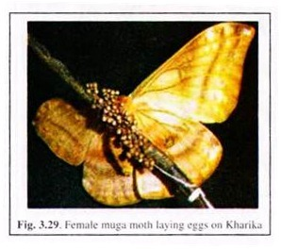
The larvae immediately crawl and start feeding on leaves. When the
leaves are exhausted, the larvae crawl down and are collected on triangular bamboo sieves with long handles (Chaloni) which are again hanged on a fresh tree.
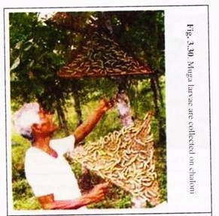
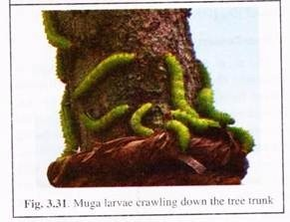
A band of straw with a little sand or ash is tied around the tree trunk 1-1.2 m above the ground to prevent the worms from crawling down the ground. The larvae feed voraciously, pass through 4 moults and reach the mature stage.
In the final stage, larvae become greenish blue with prominent tubercles. Larval period lasts for 30-35 days. The ripeworms come down the trees searching for a suitable place for spinning of cocoon. They are then collected by rearers and put in baskets containing mango twigs and leaves, which are set as cocoonages (Jali) for the spinning of cocoons.
The jalies left undisturbed in separate rooms or at some shady place till cocoons are formed. Dry leaves of singari, bhomloti, azar, etc. are utilised for preparation of jali by the farmers.
It is believed that cocooning in singari leaves produces shining and compact cocoons. Spinning takes about 2-3 days in summer and 7 days in winter. Muga cocoon is golden or light brown in colour, 4-6 cm long and 2-3 cm broad with a rudimentary peduncle without ring .

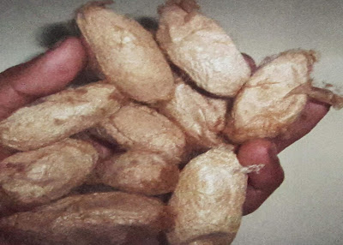

Post-Cocoon Processing:

The muga cocoon is compact and leathery in structure. The length of continuous silk filament ranges from 350-450 metres with 4 to 5 breaks. Immediately after removal from the mountages, cocoons are spread on bamboo mats in the sun during hot hours of the day that partially kills the chrysalis.
These are then subjected to heating in oven that kills the chrysalis completely, and thus the cocoons are stifled. For degumming of cocoon, local people use alkali (khar) made by burning banana peel/pseudo- stem or paddy straw/husk. Cocoons are boiled in such mild alkaline solutions for about 15-20 minutes.
Almost entire reeling of muga is done with a primitive machine, called Bhir or Bhawri, operated by two persons . The cocoons are kept in basin with warm water.
Reeling requires two persons:
One person releases the filaments from cocoons while the other twists the filament into one thread and wind it on Bhir. Two persons can reel around 100 gm raw silk per day on an average. Only 40-45% silk filament is reeled and rest is rejected as waste.
Muga silk:
The silk produced is called ‘muga silk’. It is golden yellow is colour, more strong, durable and lustrous. It needs no bleaching or dying and is stain resistant. Muga farmers also produce ghisha or spun muga yarn known as jotha-muga from pierced/flimsy cocoons.
Ahimsa silk/piece silk:
This silk is woven from cocoons after the moth has flown away from the cocoon, so that the worm escapes the dip in the fatal boiling hot pail of water. Traditionally eri silk is the best example of ahimsa silk. Mr. Kusuma Rajaiah of A. P. discovered this silk.
Unlike the traditional method, where pupae are killed before reeling the yarn from the cocoon, in the production of nonviolent silk, the adult moth is allowed to emerge alive from the cocoon. Then the silk thread is spun from open ended eri or tasar cocoons and from pierced muga cocoons that have been used for breeding or those found in jungles .
The silk fibres are then extracted from those abandoned cocoons. These silk is hand-spun and hand-woven. So it takes much time and costly than the traditional silk. Non-violent or piece or ahimsa silk is made essentially from non-mulberry silk cocoons.

ga

