Biosynthesis of Palmitic acid:

Palmitic acid, or hexadecanoic acid in IUPAC nomenclature, is the most common saturated fatty acid found in animals, plants and microorganisms.[9][10] Its chemical formula is CH3(CH2)14COOH, and its C:D is 16:0. It is a major component of the oil from the fruit of oil palms (palm oil), making up to 44% of total fats. Meats, cheeses, butter, and other dairy products also contain palmitic acid, amounting of 50-60% of total fats. Palmitates are the salts and esters of palmitic acid
Excess carbohydrates in the body are converted to palmitic acid. Palmitic acid is the first fatty acid produced during fatty acid synthesis and is the precursor to longer fatty acids. As a consequence, palmitic acid is a major body component of animals. In humans, one analysis found it to make up 21–30% (molar) of human depot fat, and it is a major, but highly variable, lipid component of human breast milk. Palmitate negatively feeds back on acetyl-CoA carboxylase (ACC), which is responsible for converting acetyl-CoA to malonyl-CoA, which in turn is used to add to the growing acyl chain, thus preventing further palmitate generation.[17] In biology, some proteins are modified by the addition of a palmitoyl group in a process known as palmitoylation. Palmitoylation is important for membrane localisation of many proteins.
The synthesis of palmitate requires the input of 8 molecules of acetyl CoA, 14 molecules of NADPH, and 7 molecules of ATP. Fatty acids are synthesized in the cytosol, whereas acetyl CoA is formed from pyruvate in mitochondria. Hence, acetyl CoA must be transferred from mitochondria to the cytosol.

Steps involved in Biosynthesis of Saturated Fatty acids:

Acetyl Coenzyme A:
- Coenzyme A consists of and chain made up of ADP, pantothenic acid, and triethanolamine, with an H₂S group on the end which binds the acetate group of acetyl CoA.
- Acetyl CoA is produced in the matrix of the mitochondria, but fatty acid biosynthesis occurs in the cytosol.
- Citrate synthase frees CoA from acetyl CoA and condenses acetate and oxaloacetate to citrate.
- Matrix membrane transporters for citrate move citrate to the cytosol, where it is acted upon by citrate lyase in the presence of CoA to re-form acetyl CoA and oxaloacetate.
- The oxaloacetate produced is converted to malate, and then to pyruvate, which is transported back to the mitochondrial matrix

The conversion of malate to pyruvate releases NADPH into the cytosol, which is necessary for fatty acid biosynthesis. (The hexose monophosphate shunt, pentose phosphate pathway, is the other major source for cytosolic NADPH.)

Palmitic acid (16:0, PA) is the most common saturated fatty acid found in the human body and can be provided in the diet or synthesized endogenously from other fatty acids, carbohydrates and amino acids. PA represents 20–30% of total fatty acids (FA) in membrane phospholipids (PL), and adipose triacylglycerols (TAG) . On average, a 70-kg man is made up of 3.5 Kg of PA. As the name suggests, PA is a major component of palm oil (44% of total fats), but significant amounts of PA can also be found in meat and dairy products (50–60% of total fats), as well as cocoa butter (26%) and olive oil (8–20%). Furthermore, PA is present in breast milk with 20–30% of total fats (Innis, 2016). The average intake of PA is around 20–30 g/d representing about 8–10 % . PA tissue content seems to be controlled around a well-defined concentration, since changes in its intake do not influence significantly its tissue concentration (Innis and Dyer, 1997; Song et al., 2017), because the intake is counterbalanced by PA endogenous biosynthesis via de novo lipogenesis (DNL). Particular physiopathological conditions and nutritional factors may strongly induce DNL, resulting in increased tissue content of PA and disrupted homeostatic control of its tissue concentration

Endogenous PA Biosynthesis by DNL and Metabolic Outcomes
FA synthesis starts with citrate conversion to acetyl-CoA and then malonyl-CoA, which is then elongated to form palmitate and other FA. Key enzymes in this process are acetyl-CoA carboxylase (ACC), which catalyzes the DNL limiting step reaction, and the FA synthase (FAS). The main sources of citrate for DNL are glucose and glutamine-derived α-ketoglutarate (α-KG), especially under hypoxia or disruption of the mitochondrial oxidative machinery . Carbohydrate feeding, beyond the body capacity to store it as glycogen or use it as energy substrate, promotes DNL by inducing a raise of insulin and substrate availability. Insulin stimulates the transcription factor Sterol Regulatory Element-Binding Proteins-1c (SREBP-1c) which up-regulates the enzymes that catalyze lipogenesis . Glucose also stimulates lipogenesis by activating the transcription factor of carbohydrate-binding protein (ChREBP) . Like SREBP-1c, ChREBP induces different genes involved in fatty acid biosynthesis . Unlike glucose, fructose, being taken up almost totally by the liver , cannot be used for glycogen biosynthesis and is promptly converted to glyceraldehyde-3-phosphate, providing a substrate for DNL. The yearly consumption of fructose has gradually increased and likely contributes to the raise of non-alcoholic fatty liver disease (NAFLD) .
DNL is a highly conserved pathway also present in invertebrate species where the survival capability seems to be related to their ability to store energy reserves as fat from different sugars in the diet.

This anabolic process is accomplished using a different set of enzymes than the catabolism of fatty acids . Fatty acid synthesis starts with the formation of palmitic acid (C16) from acetyl-CoA and malonyl-CoA (which is itself a 3-carbon molecule formed from acetyl-CoA). Another difference between the catabolic and anabolic reactions for fatty acids is the location: whereas we saw that catabolism occurs largely in the mitochondria, fatty acid synthesis is run from a single large cytoplasmic enzyme complex. The fatty acid synthase system is comprised of seven enzymes linked together with an acyl carrier protein (ACP). As mentioned, this complex is found in the cytoplasm, so its substrates must be as well. The acetyl-CoA in the cytoplasm is primarily derived from the mitochondrial acetyl-CoA via a citrate-malate shuttle that couples deacetylation in the mitochondrion with acetylation in the cytosol.

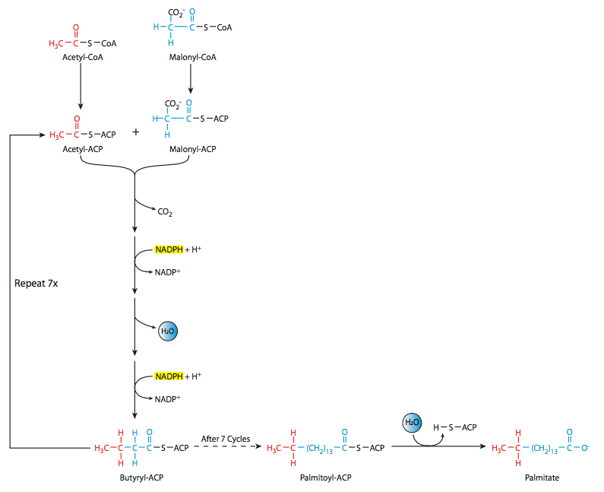
Fig:Biosynthesis of Palmitic acid.
The acetyl-CoA and malonyl-CoA are linked to the synthase and ACP, then there is a sequence of acetyl group transfers that runs a total of seven times to form palmitoyl-ACP, from which the palmitic acid is finally released. Palmitic acid is the precursor for variety of long-chain fatty acids such as stearic acid, palmitoleic acid, and oleic acid. Generally, there is either an elongation or sometimes a desaturation step. However, desaturation is a tricky process for vertebrates. The desaturation at C9 to form oleic acid from stearic acid can occur; however, other desaturations such as desaturation at C-12 to generate linoleic acid are not possible in vertebrates. Interestingly, they can be carried out in plant species. Furthermore, even though linoleic acid cannot be synthesized by vertebrates, it is nevertheless needed by vertebrates, which build arachidonic acid, prostaglandins, and other molecules from it. Linoleic acid is therefore considered an essential fatty acid, since it must be ingested by the animal.
These fatty acids are then used to form the triacylglycerols that form the bulk of the energy storage molecules in most animals. Triacylglycerols are synthesized by the reaction of fatty acyl-CoA chains with glycerol-3-phosphate. Two rounds of this reaction yields diacylglygerol-3-phosphate (phosphatidic acid). After the action of phosphatidate phosphatase, the phosphatidic acid is converted to 1,2-diacylglycerol. This reacts with fatty acyl-CoA to form the final triacyglycerol.
Each of the fatty acyl chain additions generates an ester bond, which requires a significant energy input: that energy comes from a linked ATP hydrolysis reaction for each chain addition.

Regulation of fatty acid synthesis
Acetyl-CoA carboxylase is the regulatory enzyme for fatty acid synthesis. This enzyme is regulated both allosterically and through covalent modification. It is allosterically activated by high levels of citrate and inhibited by its product, fatty acyl-CoA. It can also be inhibited by elevated levels of glucagon, epinephrine, and AMPKinase mediated phosphorylation. Insulin will stimulate the dephosphorylation and activation of the enzyme such that it can be active in the fed state . acetyl-CoA carboxylase is highly regulated within the cytosol.

