What Are Looms?
Looms are the devices used to weave. They are what hold the longitudinal warp threads in place as the weaver weaves the “filling” or weft threads through them. The weaver can choose different colours to create specific patterns. They can also change the method of this weave to create different textures or patterns.

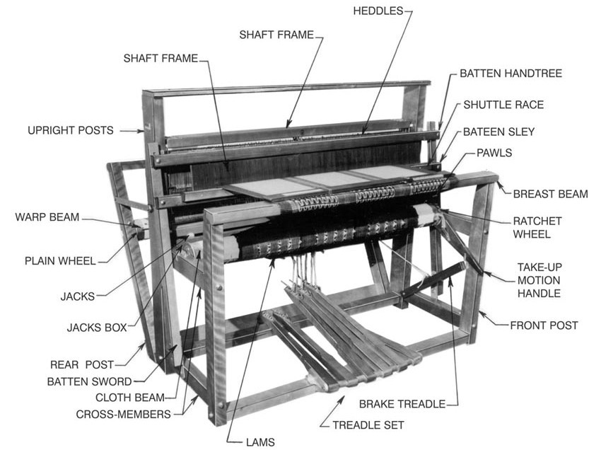
[Above: Parts of the Loom]
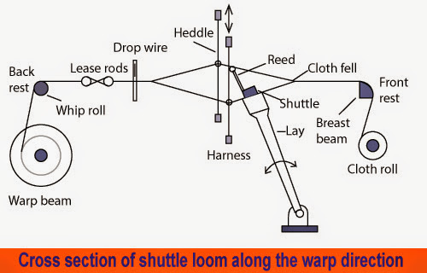

Different parts of a loom
- Warp Beam
- Weft Beam
- Harness
- Batten
- Reed
- Selvedge
- Woven Cloth
- Cloth Beam
- Fell or edge of cloth
- Shed
- Weft
- Shuttle
- Bobbin
- Dent
- Heddle
- Heddle Eye

The Parts of A Loom
- The warp beam: This is the roller on which the warp ends are wound for weaving. It is also known as a warp roll.
- Shaft/Harness: The shaft or harness is the frame of the loom that holds the warp threads. These shafts can be moved up or down by “treadles” to allow the weft to cross through and create the desired pattern. The more the number of harnesses, the more patterns you can create. The number of harnesses can range anywhere between two and sixteen. A four harness loom, for example, has four shafts that hold heddles through which the warp passes. Four harness weaves may either be plain weave or twills.
- Heddles: Heddles are made of wire or cord. These hang from the shaft of a loom and have an eye in the center. The warp is threaded through the eye of the heddle and there are as many heddles as there are warp threads. Heddles are crucial to the weaving process because it is these heddles that are raised or lowered when the shaft is moved, causing the warp to be moved for interlacing with the weft to create the pattern. The distribution of the heddles is determined by the pattern to be woven.
- Shuttle: This is the tool that holds the yarn and carries it across the warps to create the weave. Have you ever seen weavers moving threads across the loom from one end to another using a piece of wood? These wooden structures are shuttles and they have notches at the end to hold the weft yarn.
- Reed or Batten: The reed is a comb-like frame with vertical slits that secures the weft in place as it is woven in. It helps to keep the warp untangled and guides the shuttle across the loom.
- Cloth Beam: It is placed within the front of the loom nearest to the weaver on that the plain-woven textile is wound. Thereafter, it is for winding the cloth in a way of continuous process.

