Definition of phosphate pentose pathways
The pentose phosphate pathway (also called the phosphogluconate pathway and the hexose monophosphate shunt) is a metabolic pathway parallel to glycolysis. It generates NADPH and pentoses (5- carbon sugars) as well as ribose 5-phosphate, a precursor for the synthesis of nucleotides.

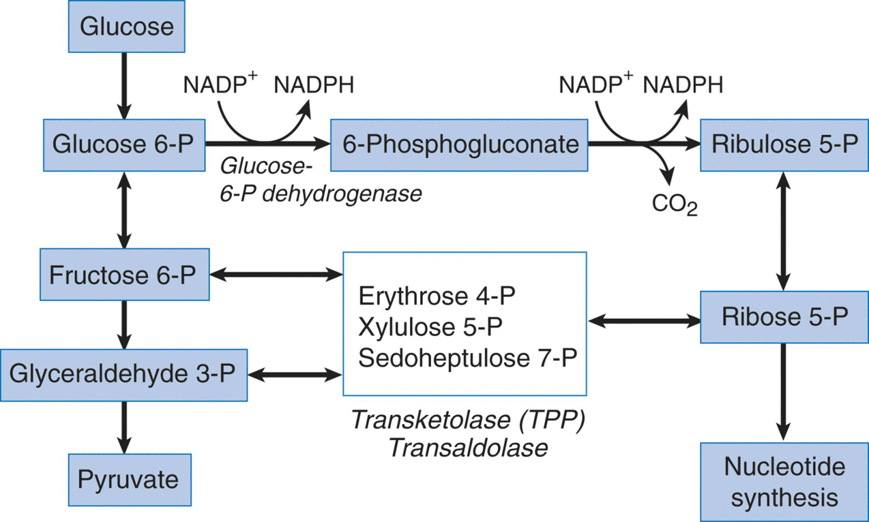

Description:

Pentose phosphate pathway also called HMP pathway that stands for Hexose Mono- Phosphate Pathway. It is very different from the other pathways, where it neither releases ATP nor consumes ATP during the process. It is a metabolic pathway that occurs in all types of cells and tissues.
In the liver, 30% of glucose is metabolized by the Pentose phosphate pathway. The HMP pathway primarily occurs in the Cytoplasm. It produces NADPH, whose 50% is utilized by the cells in the synthesis of fatty acids.

- Pentose Phosphate Pathway Steps
  - Oxidative Phase

  - Non-oxidative Phase

Oxidative Phase
The oxidative phase of HMP pathway includes the following series of reactions:
Step-1: First, six glucose 6-phosphate molecules will oxidize into 6-phosphoglucolactone in the presence of six coenzyme NADP molecules. Glucose 6-phosphate dehydrogenase catalyzes the conversion of the first step in PPP (Pentose phosphate pathway) and results in the release of six NADPH₂ molecules.
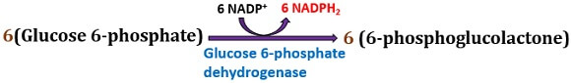
Step-2: Then, the six 6-phosphoglucolactone molecules hydrolyze into 6-phosphogluconic acid by the water. Lactonase catalyzes this conversion.

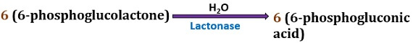
Step-3: Later, six 6-phosphogluconic acid molecules undergo oxidative carboxylation into ribulose 5-phosphate in the presence of six NADP (coenzyme) molecules. An enzyme phosphogluconic acid dehydrogenase catalyzes this conversion. This step releases six NADPH₂ molecules.
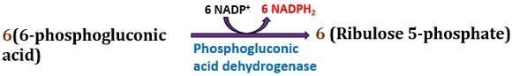

Non-oxidative Phase
Step-4: After that, six ribulose 5-phosphate molecules undergo isomerization by an enzyme ribulose phosphate 3-epimerase and pentose phosphate isomerase into four xylulose 5-phosphate molecules and two ribose 5-phosphate molecules, respectively.
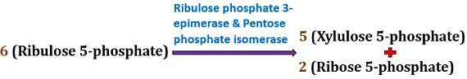
Step-5: Then, two xylulose 5-phosphate molecules and two ribose 5-phosphate molecules combine to form 2 molecules each of sedoheptulose 7-phosphate and 3-phosphoglyceraldehyde. This reaction is catalyzed by transketolase.

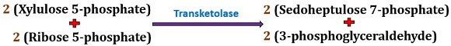

Step-6: After that, two sedoheptulose 7-phosphate molecules and 3- phosphoglyceraldehyde molecules combine to form 2 molecules each of fructose 6-phosphate and erythrose 4-phosphate, respectively. This reaction is catalyzed by transaldolase.

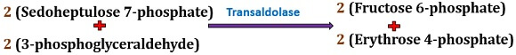

Step-7: Then, a molecule of 3- phosphoglyceraldehyde isomerizes into dihydroxyacetone-phosphate by an enzyme phosphotriose isomerase.
Step-8: Then, a molecule of 3- phosphoglyceraldehyde combines with the dihydroxyacetone-phosphate and converts into fructose 1,6-biphosphate by an enzyme aldolase. Fructose 1, 6-biphosphate further converts into fructose 6-phosphate by an enzyme “phosphatase”.
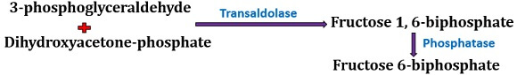
Step-9: At last, five fructose 6-phosphate molecules convert into five glucose 6-phosphate molecules via an enzyme phosphohexose isomerase.
Net production: The net production in the HMP pathway includes six CO₂ molecules and 6 NADPH₂ molecules.

Significance
Pentose phosphate pathway is an alternative pathway for the carbohydrate degradation or breakdown as it directly oxidizes the glucose 6-phosphate without entering into the glycolysis cycle. Ribulose 5-phosphate being a primary acceptor of CO₂, it participates in the CO₂ fixation of the photosynthetic organisms during the Calvin-cycle. Ribulose 5-phosphate also helps in the synthesis of Riboflavin.

Another intermediate of PPP is ribose 5-phosphate, which helps in the nucleotide and nucleic acid synthesis. Erythrose 4-phosphate helps in the synthesis of phenylalanine, tryptophan, tyrosine etc. Sedoheptulose 7-phosphate helps in the synthesis of heptoses in the lipopolysaccharide layer of gram-negative bacteria.
The NADPH₂ produced in the HMP pathway helps in the reduction biosynthesis of fatty acids, steroid hormones etc. The HMP pathway also plays an essential role in the RBCs to produce NADPH₂, as they lack mitochondria. It is the only cytoplasmic pathway that generates NADPH₂ as a sole energy source, but not ATP.

