Respiratory mitochondrial chain

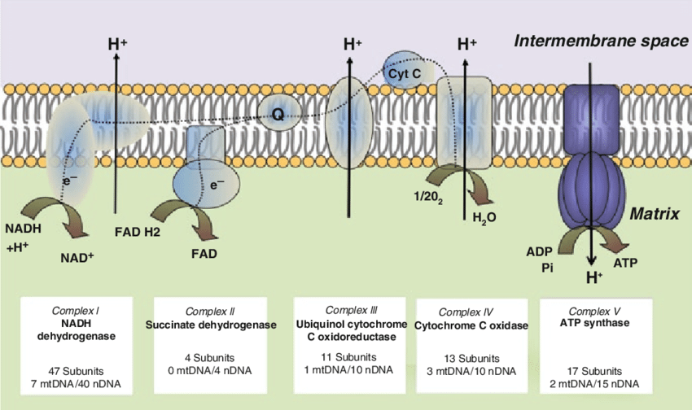

The respiratory chain involves four large protein complexes (I–IV) as well as ATP synthase (AS). All of these are embedded in the inner mitochondrial membrane. Coenzyme Q (Q) and cytochrome C (C) are diffusible electron carriers.

Functional stages in the respiratory chain

- H₂ is abstracted from NADH+H⁺ and from FADH₂
- The electrons obtained with the hydrogen are passed down a cascade of carrier molecules located in complexes I–IV, then transferred to O₂
- Powered by electron transport, complexes I, III, and IV expel protons across the inner mitochondrial membrane
- The expelled protons re-enter the mitochondrion through ATP synthase, driving ATP synthesis
The electron transport chain (ETC) comprises complexes I–IV. Hydrogen is acquired by complexes I and II from NADH and FADH₂, respectively. The electrons are then passed down the chain to complex IV, which transfers them to molecular oxygen; the reduced oxygen then reacts with protons to yield water.
Complexes I, III and IV extract energy from the electron flow and use it to expel protons across the membrane. For each electron migrating down the chain, multiple protons are pumped out of the mitochondrion. The protons accumulated outside the mitochondrion are allowed back in through ATP synthase. This protein is a molecular motor, driven to rotate by the flow of protons through it into the mitochondrial matrix. The rotary motion of ATP synthase in turn drives the synthesis of ATP from ADP and phosphate.

