Catabolism vs Anabolism:

Metabolism is a biochemical process that allows an organism to live, grow, reproduce, heal, and adapt to its environment. Anabolism and catabolism are two metabolic processes, or phases. Anabolism refers to the process which builds molecules the body needs; it usually requires energy for completion. Catabolism refers to the process that breaks down complex molecules into smaller molecules; it usually releases energy for the organism to use.

Anabolism:
Anabolic processes use simple molecules within the organism to create more complex and specialized compounds. This synthesis, the creation of a product from a series of components, is why anabolism is also called "biosynthesis." The process uses energy to create its end products, which the organism can use to sustain itself, grow, heal, reproduce or adjust to changes in its environment. Growing in height and muscle mass are two basic anabolic processes. At the cellular level, anabolic processes can use small molecules called monomers to build polymers, resulting in often highly complex molecules. For example, amino acids (monomers) can be synthesized into proteins (polymers).
Typically, anabolic and catabolic reactions are coupled, with catabolism providing the activation energy for anabolism. The hydrolysis of adenosine triphosphate (ATP) powers many anabolic processes. In general, condensation and reduction reactions are the mechanisms behind anabolism.

Anabolism Examples
Anabolic reactions are those that build complex molecules from simple ones. Cells use these processes to make polymers, grow tissue, and repair damage. For example:
- Glycerol reacts with fatty acids to make lipids:
CH₂OHCH(OH)CH₂OH + C₁₇H₃₅COOH → CH₂OHCH(OH)CH₂OOCC₁₇H₃₅
- Simple sugars combine to form disaccharides and water:
C₆H₁₂O₆ + C₆H₁₂O₆ → C₁₂H₂₂O₁₁ + H₂O
- Amino acids join together to form dipeptides:
NH₂CHRCOOH + NH₂CHRCOOH → NH₂CHRCONHCHRCOOH + H₂O
- Carbon dioxide and water react to form glucose and oxygen in photosynthesis:
6CO₂ + 6H₂O → C₆H₁₂O₆ + 6O₂
Anabolic hormones stimulate anabolic processes. Examples of anabolic hormones include insulin, which promotes glucose absorption, and anabolic steroids, which stimulate muscle growth. Anabolic exercise is anaerobic exercise, such as weightlifting, which also builds muscle strength and mass.

Catabolism:
Catabolic processes break down complex compounds and molecules to release energy. This creates the metabolic cycle, where anabolism then creates other molecules that catabolism breaks down, many of which remain in the organism to be used again.
The principal catabolic process is digestion, where nutrient substances are ingested and broken down into simpler components for the body to use. In cells, catabolic processes break down polysaccharides such as starch, glycogen, and cellulose into monosaccharides (glucose, ribose and fructose, for example) for energy. Proteins are broken down into amino acids, for use in anabolic synthesis of new compounds or for recycling. And nucleic acids, found in RNA and DNA, are catabolized into nucleotides as part of the body's energy needs or for the purpose of healing.

Catabolism Examples
Catabolic processes are the reverse of anabolic processes. They are used to generate energy for anabolism, release small molecules for other purposes, detoxify chemicals, and regulate metabolic pathways. For example:
- During cellular respiration, glucose and oxygen react to yield carbon dioxide and water
C₆H₁₂O₆ + 6O₂ → 6CO₂ + 6H₂O
- In cells, hydroxide peroxide decomposes into water and oxygen:
2H₂O₂ → 2H₂O + O₂
Many hormones act as signals to control catabolism. The catabolic hormones include adrenaline, glucagon, cortisol, melatonin, hypocretin, and cytokines. Catabolic exercise is aerobic exercise such as a cardio workout, which burns calories as fat (or muscle) is broken down.
A metabolic pathway that can be either catabolic or anabolic depending on energy availability is called an amphibolic pathway. The glyoxylate cycle and the citric acid cycle are examples of amphibolic pathways. These cycles can either produce energy or use it, depending on cellular needs.

Stages of catabolism:
Animals obtain chemical energy from the food—carbohydrates, fats, and proteins—they eat through reactions defined collectively as catabolism. We can think of catabolism as occurring in three stages.
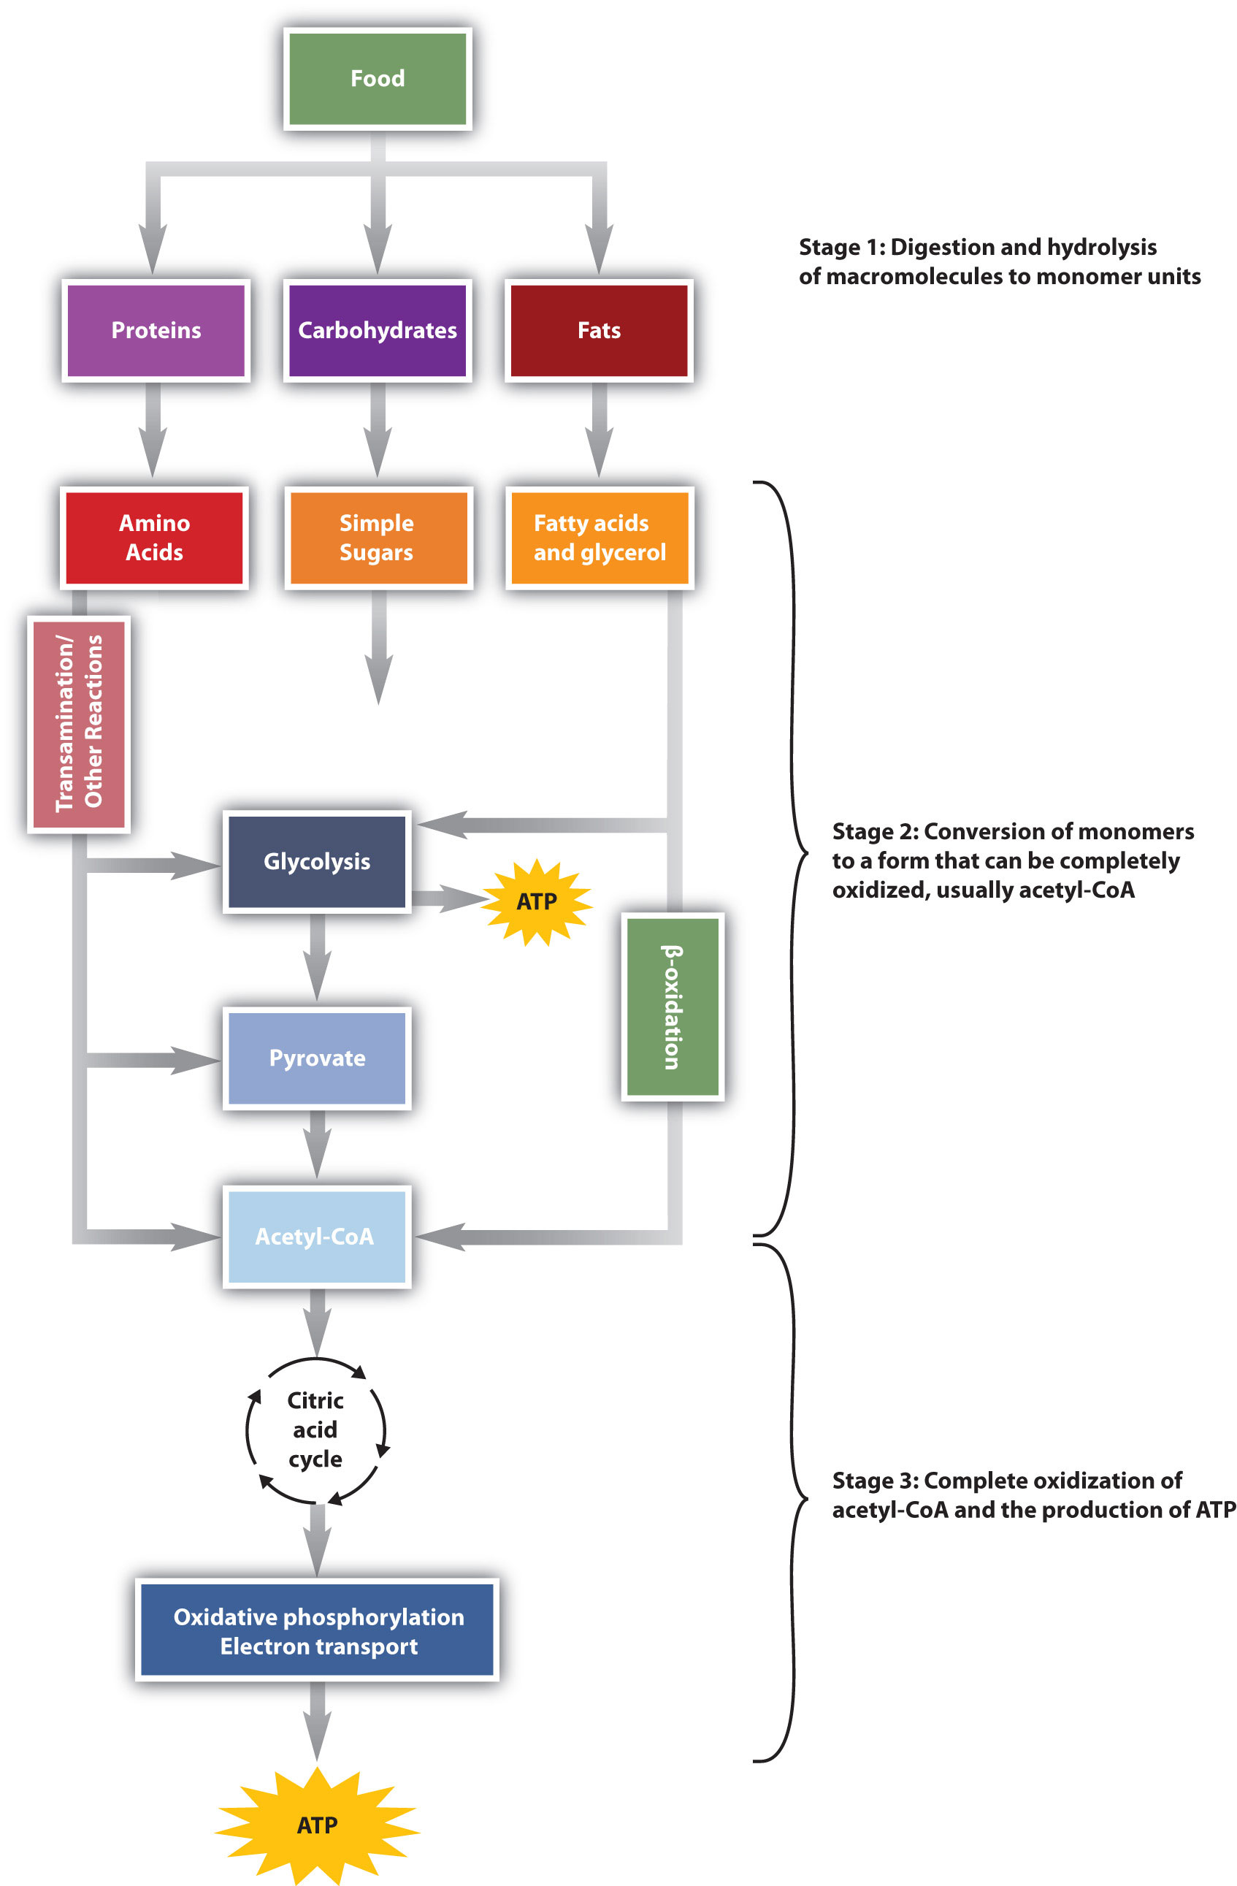
In stage I, carbohydrates, fats, and proteins are broken down into their individual monomer units: carbohydrates into simple sugars, fats into fatty acids and glycerol, and proteins into amino acids. One part of stage I of catabolism is the breakdown of food molecules by hydrolysis reactions into the individual monomer units—which occurs in the mouth, stomach, and small intestine—and is referred to as digestion.
In stage II, these monomer units (or building blocks) are further broken down through different reaction pathways, one of which produces ATP, to form a common end product that can then be used.
In stage III to produce even more ATP.

Carbohydrate digestion begins in the mouth where salivary α-amylase attacks the α-glycosidic linkages in starch, the main carbohydrate ingested by humans. Cleavage of the glycosidic linkages produces a mixture of dextrins, maltose, and glucose. The α-amylase mixed into the food remains active as the food passes through the esophagus, but it is rapidly inactivated in the acidic environment of the stomach.
The primary site of carbohydrate digestion is the small intestine. The secretion of α-amylase in the small intestine converts any remaining starch molecules, as well as the dextrins, to maltose. Maltose is then cleaved into two glucose molecules by maltase. Disaccharides such as sucrose and lactose are not digested until they reach the small intestine, where they are acted on by sucrase and lactase, respectively. The major products of the complete hydrolysis of disaccharides and polysaccharides are three monosaccharide units: glucose, fructose, and galactose. These are absorbed through the wall of the small intestine into the bloodstream.

Protein digestion begins in the stomach , where the action of gastric juice hydrolyzes about 10% of the peptide bonds. Gastric juice is a mixture of water (more than 99%), inorganic ions, hydrochloric acid, and various enzymes and other proteins. The hydrochloric acid (HCl) in gastric juice is secreted by glands in the stomach lining. The pH of freshly secreted gastric juice is about 1.0, but the contents of the stomach may raise the pH to between 1.5 and 2.5. HCl helps to denature food proteins; that is, it unfolds the protein molecules to expose their chains to more efficient enzyme action. The principal digestive component of gastric juice is pepsinogen, an inactive enzyme produced in cells located in the stomach wall. When food enters the stomach after a period of fasting, pepsinogen is converted to its active form—pepsin—in a series of steps initiated by the drop in pH. Pepsin catalyzes the hydrolysis of peptide linkages within protein molecules. It has a fairly broad specificity but acts preferentially on linkages involving the aromatic amino acids tryptophan, tyrosine, and phenylalanine, as well as methionine and leucine.
Protein digestion is completed in the small intestine. Pancreatic juice, carried from the pancreas via the pancreatic duct, contains inactive enzymes such as trypsinogen and chymotrypsinogen. They are activated in the small intestine as follows : The intestinal mucosal cells secrete the proteolytic enzyme enteropeptidase, which converts trypsinogen to trypsin; trypsin then activates chymotrypsinogen to chymotrypsin (and also completes the activation of trypsinogen). Both of these active enzymes catalyze the hydrolysis of peptide bonds in protein chains. Chymotrypsin preferentially attacks peptide bonds involving the carboxyl groups of the aromatic amino acids (phenylalanine, tryptophan, and tyrosine). Trypsin attacks peptide bonds involving the carboxyl groups of the basic amino acids (lysine and arginine). Pancreatic juice also contains procarboxypeptidase, which is cleaved by trypsin to carboxypeptidase. The latter is an enzyme that catalyzes the hydrolysis of peptide linkages at the free carboxyl end of the peptide chain, resulting in the stepwise liberation of free amino acids from the carboxyl end of the polypeptide.
Aminopeptidases in the intestinal juice remove amino acids from the N-terminal end of peptides and proteins possessing a free amino group. Figure illustrates the specificity of these protein-digesting enzymes. The amino acids that are released by protein digestion are absorbed across the intestinal wall into the circulatory system, where they can be used for protein synthesis.
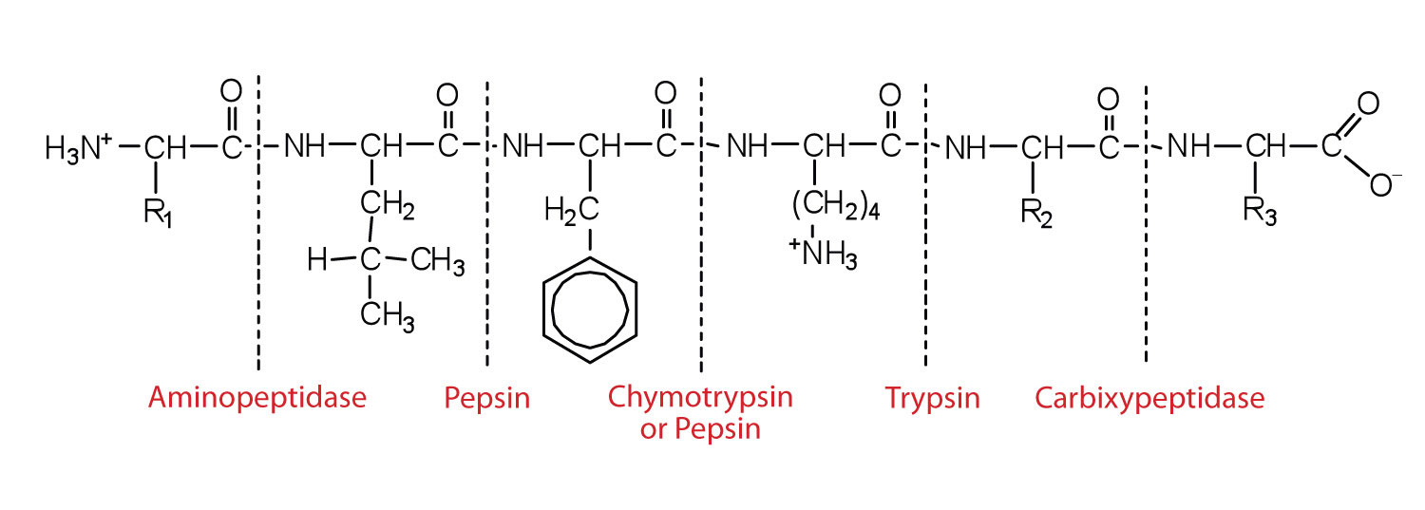
This diagram illustrates where in a peptide the different peptidases we have discussed would catalyze hydrolysis the peptide bonds.

Lipid digestion begins in the upper portion of the small intestine . A hormone secreted in this region stimulates the gallbladder to discharge bile into the duodenum. The principal constituents of bile are the bile salts, which emulsify large, water-insoluble lipid droplets, disrupting some of the hydrophobic interactions holding the lipid molecules together and suspending the resulting smaller globules (micelles) in the aqueous digestive medium. These changes greatly increase the surface area of the lipid particles, allowing for more intimate contact with the lipases and thus rapid digestion of the fats. Another hormone promotes the secretion of pancreatic juice, which contains these enzymes.
The lipases in pancreatic juice catalyze the digestion of triglycerides first to diglycerides and then to 2-monoglycerides and fatty acids:
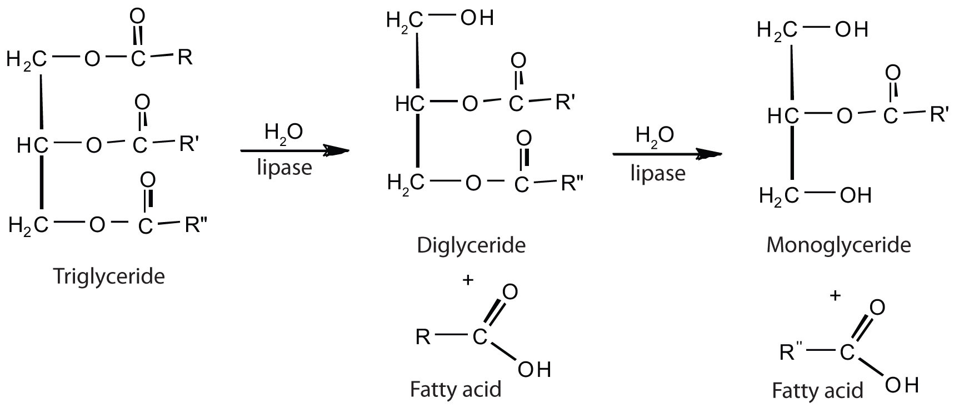
The monoglycerides and fatty acids cross the intestinal lining into the bloodstream, where they are resynthesized into triglycerides and transported as lipoprotein complexes known as chylomicrons. Phospholipids and cholesteryl esters undergo similar hydrolysis in the small intestine, and their component molecules are also absorbed through the intestinal lining.
The further metabolism of monosaccharides, fatty acids, and amino acids released in stage I of catabolism occurs in stages II and III of catabolism.

Compartmentalization of metabolic pathways:
_
All reactions occurring in cells take place in certain space – compartment, which is separated from other compartments by means of semipermeable membranes. They help to separate even chemically quite heterogeneous environments and so to optimise the course of chemical reactions.
Enzymes catalysing individual reactions often have different temperature and pH optimums and if there was only one cellular compartment a portion of enzymes would probably not function or them-catalysed reactions would not be sufficiently efficient. By dividing the cellular space, optimal conditions for individual enzymatically catalysed reactions are created.
At the same time, cell also protects itself against the activity of lytic enzymes. For example, sealing the cellular digestion in lysosomes prevents an unwanted auto-digestion of other organelles within cell. A common processes that accompany the disruption of some of the compartments (like spilling the content of lysosomes or mitochondria) are necrosis or activation of apoptosis (the process of programmed cell death).
Compartmentalization affects the regulation of metabolic pathways as well, making them more accurate and targeted and less interfering with each other. It is sometimes possible to regulate the course of the reaction at the point of entry of particular substrate into the compartment (transport across the membrane, often mediated by transport mechanisms).
Despite its advantages, compartmentalization at the same time puts greater demand on the energy consumption. It arises from a frequent need to use ATP-dependent transporters, transporting substances across membranes against the concentration gradient and thus creating different environments in different compartments. Cytoplasmic membrane creates the border with the extracellular compartment and membranes of a similar composition separate other compartments inside the cell.
Some of the examples of compartmentalization of metabolic pathways:

Cytosole (cytoplasm without organelles):
1) Metabolism of saccharides: glycolysis, part of gluconeogenesis, glycogenolysis and synthesis of glycogen, pentose cycle
2) Metabolism of fatty acids: FA synthesis
3) Metabolism of amino acids: synthesis of nonessential AA, some of the transamination reactions
4) Other pathways: parts of heme and urea synthesis pathways, metabolism of purines and pyrimidines

Mitochondria:
1) Metabolism of saccharides: PDH, part of gluconeogenesis (conversion of pyruvate to OAA)
2) Metabolism of fatty acids: beta-oxidation of FA (Linen’s spiral), synthesis (hepatocytes only) and degradation (extrahepatic tissues) of ketone bodies
3) Metabolism of amino acids: oxidative deamination, some of the transamination reactions
4) Other pathways: Krebs cycle, respiratory chain and oxidative phosphorylation, parts of heme and urea synthesis pathways.

ER:
1) Proteosynthesis (translation of mRNA).
2) Posttranslational modifications (oxidations, cleavage, methylations, phosphorylations, glycosylations).
3 TAG and phospholipid synthesis.
4 FA elongation (to a maximal length of 24 carbon atoms – in nerve tissue) and desaturation (maximally at 9th carbon atom – counted from carboxyl group).
5 Parts of steroid synthesis pathway.
6 Biotransformation of xenobiotics.
7 Conversion of glucose-6-phosphate to glucose (only in tissues with glucose-6-phosphatase).

GA:
1) Posttranslational modifications (glycosylations, …)
2) Proteins sorting and formation of secretory vesicles

Lysosomes:
1) Hydrolysis of proteins, saccharides, lipids and nucleic acids

Peroxisomes:
- Degradation of long-chain FA (> 20 carbon atoms)

Shuttle system and membrane transporter
One major mechanism for the regulation of metabolic processes within eukaryotic cells is related to the fact that most processes are located in specific compartments within the cell. This means that separate pools of some important metabolites are maintained in different locations, allowing the movement of the molecules between these pools to act as an additional level of regulation. This separation is especially obvious for the mitochondria, where the inner membrane is a barrier to the transit of most molecules.
Mitochondrial shuttle system:
A few molecules can cross the mitochondrial inner membrane unassisted. These include small, uncharged molecules (e.g., CO2, O2, and NH3), and some small carboxylic acids, probably in their uncharged forms (e.g., protonated acetic acid). Otherwise, only molecules that have specific transporter proteins are capable of crossing the mitochondrial membrane.
ATP/ADP and Phosphate pumps The oxidative phosphorylation pathway generates ATP inside the mitochondria. However, most ATP-dependent processes occur in other compartments in the cell. Therefore, ATP must be pumped out of the mitochondria, and the ADP and inorganic phosphate generated elsewhere must be pumped in. The ATP translocator is not actually a pump; however, because ATP4– has more charges than ADP3–, the proton gradient tends to force the ATP out of the mitochondria even in the face of an opposing concentration gradient. Phosphate also must be moved into the mitochondria to allow ATP synthesis; the movement of phosphate can be driven by a proton gradient-dependent pump
Shuttle: Shuttles are systems of enzymes and transporters. The enzymes convert molecules into metabolites that are capable of crossing membranes via the transporters, a process that is frequently followed by reformation of the original molecule. The electrons of NADH produced in the cytoplasm must be transported into the mitochondria for conversion to ATP by the electron transport pathway. Because the NADH itself cannot cross the mitochondrial membrane, one important function of shuttle mechanisms is the transport of reducing equivalents across the mitochondrial membrane. Two separate methods are used for this purpose: the Glycerophosphate shuttle and the Malate-Aspartate shuttle.

.
Glycerophosphate shuttle:
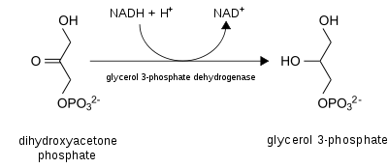

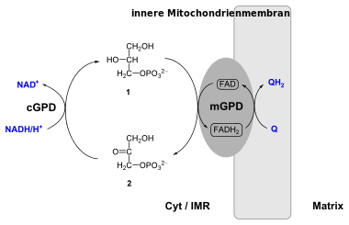
Glycerol Phosphate Shuttle
The glycerol-3-phosphate shuttle is a mechanism that regenerates NAD+ from NADH, a by-product of glycolysis. GPD1 is a gene that codes for proteins responsible for converting dihydroxyacetone phosphate and NADH to glycerol-3-phosphate and NAD+ in order to conduct bodily metabolic processes. The gene GPD2 is responsible for the reverse reaction. Its importance in transporting reducing equivalents is secondary to the malate-aspartate shuttle.
Glycerol-3-phosphate gets converted back to dihydroxyacetone phosphate by an inner membrane-bound mitochondrial glycerol-3-phosphate dehydrogenase 2 (GPDH-M), this time reducing one molecule of enzyme-bound flavin adenine dinucleotide (FAD) to FADH₂. FADH₂ then reduces coenzyme Q (ubiquinone to ubiquinol) which enters into oxidative phosphorylation.^{[3]} This reaction is irreversible.
The glycerol-3-phosphate shuttle allows the NADH synthesized in the cytosol by glycolysis to contribute to the oxidative phosphorylation pathway in the mitochondria to generate ATP.

Malate-aspartate shuttle:
The malate-aspartate shuttle (sometimes simply the malate shuttle) is a biochemical system for translocating electrons produced during glycolysis across the semipermeable inner membrane of the mitochondrion for oxidative phosphorylation in eukaryotes. These electrons enter the electron transport chain of the mitochondria via reduction equivalents to generate ATP. The shuttle system is required because the mitochondrial inner membrane is impermeable to NADH, the primary reducing equivalent of the electron transport chain. To circumvent this, malate carries the reducing equivalents across the membrane.
The shuttle consists of four protein parts:
- malate dehydrogenase in the mitochondrial matrix and intermembrane space.
- aspartate aminotransferase in the mitochondrial matrix and intermembrane space.
- malate-alpha-ketoglutarate antiporter in the inner membrane.^{[1]}
- glutamate-aspartate antiporter in the inner membrane.

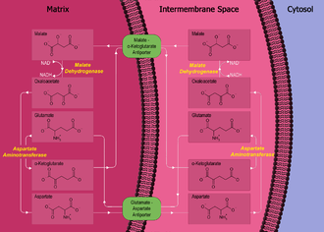

Mechanism
The primary enzyme in the malate-aspartate shuttle is malate dehydrogenase. Malate dehydrogenase is present in two forms in the shuttle system: mitochondrial malate dehydrogenase and cytosolic malate dehydrogenase. The two malate dehydrogenases are differentiated by their location and structure, and catalyze their reactions in opposite directions in this process.
First, in the cytosol, malate dehydrogenase catalyses the reaction of oxaloacetate and NADH to produce malate and NAD⁺. In this process, two electrons generated from NADH, and an accompanying H⁺, are attached to oxaloacetate to form malate.
Once malate is formed, the first antiporter (malate-alpha-ketoglutarate) imports the malate from the cytosol into the mitochondrial matrix and also exports alpha-ketoglutarate from the matrix into the cytosol simultaneously. After malate reaches the mitochondrial matrix, it is converted by mitochondrial malate dehydrogenase into oxaloacetate, during which NAD⁺ is reduced with two electrons to form NADH. Oxaloacetate is then transformed into aspartate (since oxaloacetate cannot be transported into the cytosol) by mitochondrial aspartate aminotransferase. Since aspartate is an amino acid, an amino radical needs to be added to the oxaloacetate. This is supplied by glutamate, which in the process is transformed into alpha-ketoglutarate by the same enzyme.
The second antiporter (the glutamate-aspartate antiporter) imports glutamate from the cytosol into the matrix and exports aspartate from the matrix to the cytosol. Once in the cytosol, aspartate is converted by cytosolic aspartate aminotransferase to oxaloacetate.
The net effect of the malate-aspartate shuttle is purely redox: NADH in the cytosol is oxidized to NAD⁺, and NAD⁺ in the matrix is reduced to NADH. The NAD⁺ in the cytosol can then be reduced again by another round of glycolysis, and the NADH in the matrix can be used to pass electrons to the electron transport chain so ATP can be synthesized.
Since the malate-aspartate shuttle regenerates NADH inside the mitochondrial matrix, it is capable of maximizing the number of ATPs produced in glycolysis (3/NADH), ultimately resulting in a net gain of 38 ATP molecules per molecule of glucose metabolized. Compare this to the glycerol 3-phosphate shuttle, which reduces FAD⁺ to produce FADH₂, donates electrons to the quinone pool in the electron transport chain, and is capable of generating only 2 ATPs per NADH generated in glycolysis (ultimately resulting in a net gain of 36 ATPs per glucose metabolized). (These ATP numbers are pre chemiosmotic, and should be reduced in light of the work of Mitchell and many others[. Each NADH produces only 2.5 ATPs, and each FADH₂ produces only 1.5 ATPs. Hence, the ATPs per glucose should be reduced to 32 from 38 and 30 from 36. The extra H⁺ required to bring in the inorganic phosphate during oxidative-phosphorylation contributes to the 30 and 32 numbers as well).

The activity of malate-aspartate shuttle is modulated by arginine methylation of malate dehydrogenase 1 (MDH1). Protein arginine N-methyltransferase CARM1 methylates and inhibits MDH1 by disrupting its dimerization, which represses malate-aspartate shuttle and inhibits mitochondria respiration of pancreatic cancer cells.

Coupled Reactions
This is a common feature in biological systems where some enzyme-catalyzed reactions are interpretable as two coupled half-reactions, one spontaneous and the other non-spontaneous. Organisms often the hydrolysis of ATP (adenosine triphosphate) to generate ADP (adenosine diphosphate) as the spontaneous coupling reaction .
ATP+H2O⇌ADP+Pi
- Pi is inorganic phosphate ion
- ATP is the major 'energy' molecule produced by metabolism, and it serves as a sort of 'energy source' in cell: ATP is dispatched to wherever a non-spontaneous reaction needs to occurs so that the two reactions are coupled so that the overall reaction is thermodynamically favored.

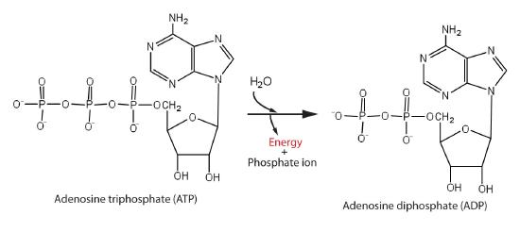

Thus two (or more) reactions may be combined such that a spontaneous reaction may be made 'drive' an nonspontaneous one. Such reactions may be considered coupled. Changes in Gibbs energy of the coupled reactions are additive.

[[
]]
[[
]]
[[
]]
[[
]]
[[
]]
[[
]]
[[
]]
[[
]]
[[
]]
[[
]]
[[
]]
[[
]]
[[
]]
[[
]]
[[
]]
[[
]]
[[
]]
[[
]]
[[
]]
[[
]]
[[
]]
[[
]]
[[
]]
[[
]]
[[
]]
[[
]]
[[
]]
[[
]]
[[
]]
[[
]]
[[
]]
[[
]]
[[
]]
[[
]]
[[
]]
[[
]]
[[
]]
[[
]]
[[
]]
[[
]]
[[
]]
[[
]]
[[
]]
[[
]]
[[
]]
[[
]]
[[
]]
[[
]]
[[
]]
[[
]]
[[
]]
[[
]]
[[
]]
[[
]]
[[
]]
[[
]]
[[
]]
[[
]]
[[
]]
[[
]]
[[
]]
[[
]]
[[
]]
[[
]]
[[
]]
[[
]]
[[
]]
[[
]]
[[
]]
[[
]]
[[
]]
[[
]]
[[
]]
[[
]]
[[
]]

