Ketogenesis:

Ketogenesis is a biochemical process that produces ketone bodies by breaking down fatty acids and ketogenic amino acids. The process supplies the needed energy of certain organs, especially the brain. It releases ketones when fat is broken down for energy. There are many ways to release ketones such as through urination and exhaling acetone. Ketones have sweet smell on the breath.

^{Steps of Ketogenesis:}
The ketogenesis process occurs primarily in the mitochondria of liver cells. Below are the steps in the process of ketogenesis:
- Transfer of fatty acids in mitochondria by carnitine palmitoyltransferase CPT-1
- Beta oxidation of fatty acid to form acetyl CoA.
- Acetoacetyl-CoA formation: 2 acetyl CoA form acetoacetyl CoA. The reaction is catalyzed by the enzyme thiolase.
- 3-hydroxy-3-methylglutaryl-CoA (HMG-CoA) synthesis: the step is catalyzed by HMG-CoA synthase.
- Acetoacetate formation: HMG-CoA is broken down to acetoacetate and acetyl-CoA by the action of HMG-CoA lyase.

Acetoacetate thus produced forms other ketone bodies, acetone by decarboxylation and D-3-hydroxybutyrate by reduction Liver, which produces ketone bodies primarily in the mitochondria, cannot utilise it due to lack of an enzyme Beta keto-acyl-CoA transferase. Acetoacetate and D-3-hydroxybutyrate are used by the body to get energy. These ketone bodies are circulated out of the liver cell. In the extrahepatic tissues, the following reactions occur:
• D-3-hydroxybutyrate is converted back to acetoacetate by beta-hydroxybutyrate dehydrogenase.
Ketogenesis process is regulated by Insulin. Hormones such as glucagon, thyroid hormones, catecholamines, cortisol increase ketogenesis rate by stimulating the breakdown of free fatty acids.
Beta-oxidation of fatty acid to form acetyl CoA 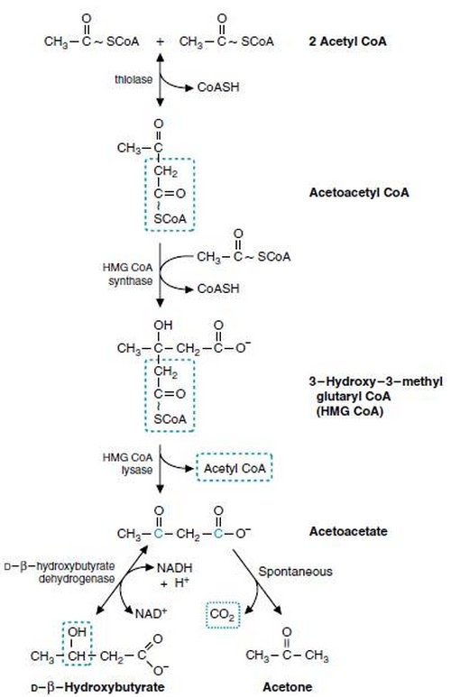
Picture : Ketogenic pathway

The process of ketogenesis mainly takes place in the mitochondria of cells of the liver. Here, fatty acids are supplied to mitochondria through carnitine
palmitoyltransferase and disintegrated into acetyl CoA via beta-oxidation
.

Significances of ketogenesis:

- Ketogenesis is used to get energy by the brain, heart and skeletal muscles under fasting condition
- The ketogenic diet (low-carb, fat-rich diet) is used these days to lose weight. The idea is to utilise excess fat stored in the body to get energy, but excess ketone bodies production can lead to various complications and ketoacidosis
- In ketoacidosis condition, the kidneys excrete extra ketone bodies with the water resulting in fluid loss
- Diabetic patients are greatly affected by ketoacidosis because insulin hormone is the main regulator of the process
- Symptoms of ketoacidosis include frequent urination, breath smelling like fruits or acetone, nausea, shortness of breath, fatigue, excessive thirst, etc.
- Level of ketone bodies present in the body can be tested by blood serum or urine sample analysis.

