Chromatin
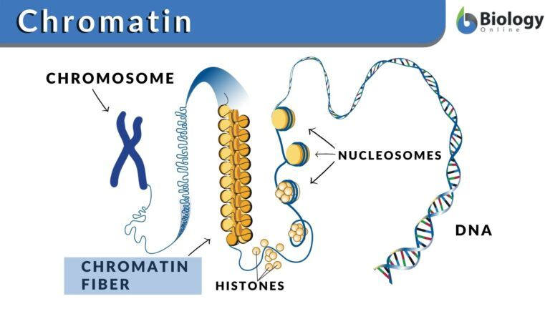
Chromatin
[Definition: A complex of nucleic acids (e.g. DNA or RNA) and proteins (e.g. histones)

Chromatin Definition
What is chromatin in a cell? Chromatin is a complex of nucleic acids (e.g. DNA or RNA) and proteins (e.g. histones). It was identified in 1882. Initially, it was thought of as just a colored substance in a nucleus, however, later it was found that chromatin is characterized as proteins attached to DNA, and DNA was identified as the carrier of genetic information (Ma, Kanakousaki, and Buttitta 2015). Thus, we can define chromatin as a substance consisting of DNA and associated proteins (known as histones).

What are histones?
Histones are positively charged basic proteins that bind to negatively charged phosphate molecules of DNA. There are two major elements in a chromatin i.e. Cell’s DNA and associated proteins. The associated proteins are known as histones. Or we can say that chromatin contains proteins called histones.
Chromatin is a packaging material for DNA. If not packed well, it can tangle around itself or get damaged during cell division. The size of cells is in micrometers and a DNA can be as long as 3 meters. In order to fit such a lengthy structure into a micrometer cell, tight packing is required.
What is nucleosome?
A DNA molecule wraps around the histone proteins to create tight loops known as nucleosomes.
The nucleosomes coil and are bundled together to form a kind of fiber known as chromatin fiber. These chromatins, in turn, also loop and fold around with the help of proteins to produce a chromosome. That’s why a chromosome is known to carry a part or all of the genetic material of an organism. Once the DNA is condensed into a chromosome it is now protected due to its tightly wounded structure. More details about its structure are in this section: Chromatin Structure.

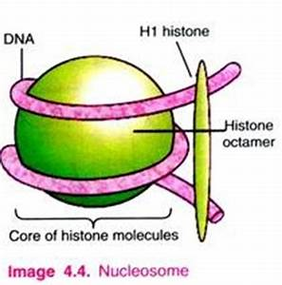

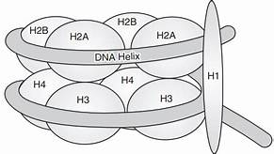
Fig:A Nucleosome .

Chromatin also plays a vital role while regulating the transfer of genetic information. Before technically defining chromatin, let’s understand what it is. Let’s look at the following diagram to understand chromatins:

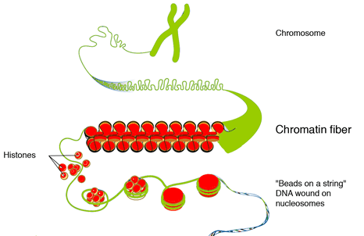

Where is chromatin found?
Where is the chromatin located? In eukaryotic cells, chromatin is found within the nucleus. Here is an illustration that will help you understand its location within the cell nucleus.
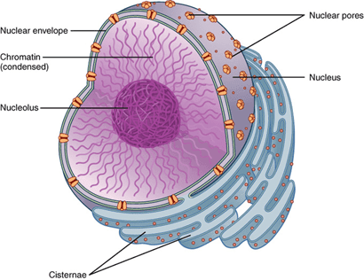

Genes in chromatin
The genes present in chromatin can either be turned off or on. It means in some cells a certain part of the gene is active (“switched on”) while the other is not (“switched off”). What is regulating this complex information from genes to proteins and mRNA? Yes, it’s the chromatin.
To validate this, the researchers used fruit fly as a model organism to study the on and off state of the genes in chromatin. The result of their study identified 5 distinct types of chromatin described by the unique presence of proteins.
These five types were then named as colors: Green, Yellow, Black, Blue, and Red. Black was totally inactive, green and blue were partially active, and yellow and red were fully active genes in the chromatin. They found out that the genes in Yellow chromatin were switched on in almost all the cells because they were regulating the vital functions of the cells. Red chromatins were switched on in some specific cells because they were governing more specific functions

this complex information from genes to proteins and mRNA? Yes, it’s the chromatin

Chromatin Structure
The histone protein and DNA have an equal mass in eukaryotic chromatin (although there are also some cells with non-histone proteins instead). The nucleosome is the structural unit of chromatin, which in turn, consists of DNA and (histone or non-histone) proteins. This structure is repeated throughout the genetic material of an organism. The structure of chromatin packing into the higher-order structure is shown below.

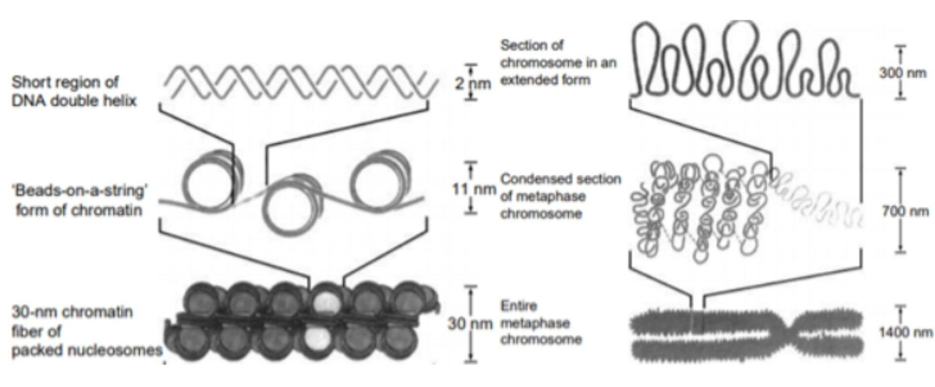

What is meant by the “beads on a string” model of chromatin?
The DNA and histone proteins provide the first level of compaction for DNA inside the nucleus. The basic unit of structure of chromatin is the nucleosome. A nucleosome is formed when DNA is wrapped around histones (the protein core) to form a “bead-like” structure. This bead-like structure is known as a nucleosome. In figure 3, the second from the top is the “beads-on-a-string” form of chromatin. The nucleosome is a complex of 146 base pairs of DNA and is wound from outside of 8 proteins, i.e. histones. Thus, DNA wrapped around histones forms a nucleosome.
There are five different types of histones, namely H1, H2A, H2B, H3, and H4. A histone core is produced when two H2A and H2B combine with H3 and H4 proteins. Approximately 145 base pairs of DNA are wrapped twice around this protein structure to form a nucleosome. The length of linker DNA can vary depending upon the species gene activity and can range between 10 to 95 base pairs. There is a nucleosome after every 200 base pairs and its length was 10 nm.

When looked through a microscope, the chromatin looks like beads fitted in the string. These beads are known as nucleosomes. The nucleosome itself is composed of eight proteins known as histones. The nucleosomes form a solenoid by wrapping themselves into a 30nm spiral. In this solenoid, additional histone proteins help form chromatin structure. The chromatin condenses into chromosomes due to increasing compact structure (Baldi, Korber, and Becker 2020).
What is the relationship between DNA and chromatin?
Chromatin is the packaging of DNA. DNA and associated proteins are packed inside chromatin to fit inside a nucleus.
How DNA is assembled in chromatin structure?
There are several steps involved in the assembly of DNA into the chromatin. In the first step, H3e and H4 proteins deposit on DNA followed by H2A and H2B. A sub-nucleosomal particle is formed consisting of 146 base pairs of DNA. The second step is maturation in which ATP establishes a consistent spacing of nucleosome cores. In the next step folding of linker histones is started in a nucleofilament of 30 nm structure. In the last step further folding occurs leading to a higher level of packing. The packing ratio is about 7000.

Euchromatin vs. Heterochromatin
There are two forms of chromatin: (1) euchromatin and (2) heterochromatin. Euchromatin is less condensed and can be transcribed whereas heterochromatin is highly condensed and cannot typically be transcribed. The heterochromatin is further classified as constitutive heterochromatin and facultative heterochromatin. The constitutive heterochromatin is the DNA sequences existing in all cells of an organism. The constitutive heterochromatin is related to highly repeated DNA. Similarly, facultative heterochromatin is not present in all cells. For instance, the gene encoding beta-globin in animals is present in certain cells but not in blood cells. As explained earlier, chromatin is a complex of proteins and DNA in eukaryotic cells. The nuclear DNA does not exist as linear strands but is tightly condensed and wrapped around nuclear proteins so that it can fit into the nucleus.
Chromatin forms: There are two forms of chromatins in the interphase nucleus, i.e. euchromatin and heterochromatin. The form of chromatin that is structurally loose is referred to as euchromatin. It is usually active in terms of transcription and replication. It is loose to allow RNA and DNA polymerases to transcribe and replicate DNA, respectively. The heterochromatin is the less active chromatin. It bears inactive genes and is relatively more condensed.

Chromatin Function
Initially, chromatin was considered as the substance that gives color to the cell nucleus. Later on, it was found that it is not just a coloring substance but is one of the most important DNA expression regulators. Chromatin structure has also an important role in the replication of DNA. The packaging of DNA in chromatin and nucleosome results in a tightly closed structure that is not accessible by enzymes that are responsible for transcription, replication, and repair of DNA.
The packaging of DNA structure is transcriptionally repressive and allows a basal level of gene expression only. For nucleosome structures that are open or disrupted, the DNA can more easily be replicated and transcribed.
During the transcription process, the chromatin structure is changed by some repressors and activators which interact with RNA to regulate the gene activity. Activators change the nucleosome structure resulting in RNA polymerase assembly stimulation. During replication, a similar regulation of chromatin structure occurs which allows the replication mechanism to be in place at the origin of replication.
Another function of chromatin is in the regulation of gene expression. Using the process of position effect variegation, the genes can be converted to transcriptionally inactive by locating them near silent heterochromatic chromatins. The distance between silent heterochromatin chromatins and genes can be up to 1000 kilobase pairs. This phenomenon is referred to as epigenetic because it produces variation in phenotype.

