Beta oxidation of saturated Fatty acids:

- Beta-oxidation is the catabolic process by which fatty acid molecules are broken down in the cytosol in prokaryotes and in the mitochondria in eukaryotes to generate acetyl-CoA.
- Acetyl-CoA enters the citric acid cycle while NADH and FADH₂, which are co-enzymes, are used in the electron transport chain.
- It is referred as “beta oxidation” because the beta carbon of the fatty acid undergoes oxidation to a carbonyl group.
Beta-Oxidation takes place in the mitochondria of eukaryotes while in the cytosol in the prokaryotes.
- Substrates: Free fatty acids; H₂O.
- Products: One acetyl CoA, one NADH, and one FADH₂ for every removal of a two-carbon group from the fatty acid chain.

Briefly, the steps in beta oxidation (the initial breakdown of free fatty acids into acetyl-CoA) are as follows:
- Dehydrogenation by acyl-CoA dehydrogenase, yielding 1 FADH2.
- Hydration by enoyl-CoA hydratase.
- Dehydrogenation by 3-hydroxyacyl-CoA dehydrogenase, yielding 1 NADH + H+.
- Cleavage by thiolase, yielding 1 acetyl-CoA and a fatty acid that has now been shortened by 2 carbons (forming a new, shortened acyl-Co

The Pathway of Beta-Oxidation
- In the mitochondria, the fatty acid undergoes a series of oxidation and hydration reactions, which results in the removal of a two-carbon group (in the form of acetyl CoA) from the fatty acid chain as well as the formation of one NADH and one FADH₂, which enter the electron transport chain to form five ATP.
- The acetyl CoA formed will enter the citric acid cycle and then the electron transport chain, leading to the formation of another 12 ATP. The cycle continues, with each turn of the cycle removing another two-carbon group, until the formerly long-chain fatty acid has been reduced to acetyl CoA or propionyl CoA.
- Propionyl CoA can be converted to succinyl CoA through three enzymatic events, which require biotin and vitamin B12 as cofactors, and then succinyl CoA can enter the citric acid cycle.

A. Activation of fatty acids
- In the cytosol of the cell, long-chain fatty acids are activated by ATP and coenzyme A, and fatty acyl-CoA is formed. Short-chain fatty acids are activated in mitochondria.
- The ATP is converted to AMP and pyrophosphate (PPi), which is cleaved by pyrophosphatase to two inorganic phosphates (2 Pi). Because two high-energy phosphate bonds are cleaved, the equivalent of two molecules of ATP is used for fatty acid activation.

B. Transport of fatty acyl-CoA from the cytosol into mitochondria
- Fatty acyl-CoA from the cytosol reacts with carnitine in the outer mitochondrial membrane, forming fatty acylcarnitine. The enzyme is carnitine acyltransferase I (CAT I), which is also called carnitine palmitoyltransferase I (CPT I). Fatty acylcarnitine passes to the inner membrane, where it re-forms to fatty acyl-CoA, which enters the matrix. The second enzyme is carnitine acyltransferase II (CAT II).
- Carnitine acyltransferase I, which catalyzes the transfer of acyl groups from coenzyme A to carnitine, is inhibited by malonyl-CoA, an intermediate in fatty acid synthesis. Therefore, when fatty acids are being synthesized in the cytosol, malonyl-CoA inhibits their transport into mitochondria and, thus, prevents a futile cycle (synthesis followed by immediate degradation).
- Inside the mitochondrion, the fatty acyl-CoA undergoes beta-oxidation.

C. β-Oxidation of even-chain fatty acids
β-Oxidation (in which all reactions involve the β-carbon of a fatty acyl-CoA) is a spiral consisting of four sequential steps, the first three of which are similar to those in the TCA cycle between succinate and oxaloacetate. These steps are repeated until all the carbons of an even-chain fatty acyl-CoA are converted to acetyl-CoA.
- FAD accepts hydrogens from a fatty acyl-CoA in the first step. A double bond is produced between the α- and β-carbons, and an enoyl-CoA is formed. The FADH₂ that is produced interacts with the electron transport chain, generating ATP.
- Enzyme: Acyl-CoA dehydrogenase (Multiple variants of this enzyme)
- H₂O adds across the double bond, and a β-hydroxyacyl-CoA is formed.
- Enzyme: Enoyl-CoA hydratase
- β -Hydroxyacyl-CoA is oxidized by NAD+ to a β-ketoacyl-CoA. The NADH that is produced interacts with the electron transport chain, generating ATP.
- Enzyme: L-3-hydroxyacyl-CoA dehydrogenase (which is specific for the L-isomer of the β-hydroxyacyl-CoA).
- The bond between the alpha and beta carbons of the β-ketoacyl-CoA is cleaved by a thiolase that requires coenzyme A. Acetyl-CoA is produced from the two carbons at the carboxyl end of the original fatty acyl-CoA, and the remaining carbons form a fatty acyl-CoA that is two carbons shorter than the original.
- Enzyme: β -ketothiolase
- The shortened fatty acyl-CoA repeats these four steps. Repetitions continue until all the carbons of the original fatty acyl-CoA are converted to acetyl-CoA.

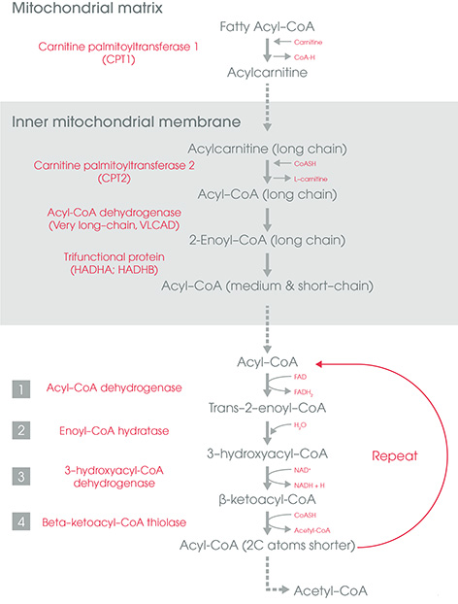
Fig:Steps of beta oxidation of fatty acid

Number of ATP forms in beta oxidation of fatty acid:

How many ATP molecules are produced during beta oxidation?
- Palmitic acid yields 7 NADH + 7 FADH 2 + 8 acetyl CoA in 7 cycles of mitochondrial beta oxidation. Every acetyl CoA yields 3 NADH + 1 FADH2 + 1 GTP (=ATP) during Krebs cycle. Considering an average production of 3 ATP per NADH and 2 ATP per FADH 2 using the respiratory chain, we have 131 ATP molecules.
Number of ATP form depend upon the number of carbon atoms present in the fatty acid molecule.
More the number of carbon atoms more will be the production of ATP and thus more will be the energy.

