Microtubules of cytoskeleton

Microtubules are polymers of tubulin that form part of the cytoskeleton and provide structure and shape to eukaryotic cells. Microtubules can grow as long as 50 micrometres and are highly dynamic. The outer diameter of a microtubule is between 23 and 27 nm^{[2]} while the inner diameter is between 11 and 15 nm.^{[3]} They are formed by the polymerization of a dimer of two globular proteins, alpha and beta tubulin into protofilaments that can then associate laterally to form a hollow tube, the microtubule.^{[4]} The most common form of a microtubule consists of 13 protofilaments in the tubular arrangement.
Microtubules are nucleated and organized by microtubule organizing centers (MTOCs), such as the centrosome found in the center of many animal cells or the basal bodies found in cilia and flagella, or the spindle pole bodies found in most fungi.
There are many proteins that bind to microtubules, including the motor proteins kinesin and dynein, microtubule-severing proteins like katanin, and other proteins important for regulating microtubule dynamics.
.
Microtubules are very important in a number of cellular processes. They are involved in maintaining the structure of the cell and, together with microfilaments and intermediate filaments, they form the cytoskeleton. They also make up the internal structure of cilia and flagella. They provide platforms for intracellular transport and are involved in a variety of cellular processes, including the movement of secretory vesicles, organelles, and intracellular macromolecular assemblies (see entries for dynein and kinesin).^{[5]} They are also involved in cell division (by mitosis and meiosis) and are the major constituents of mitotic spindles, which are used to pull eukaryotic chromosomes apart.

Structure of Microtubules
- They are long fibers (of indefinite length) about 24 nm in diameter.
- In cross-section, each microtubule appears to have a dense wall of 6 nm thickness and light or hollow center. In cross-section, the wall of a microtubule is made up of 13 globular subunits, called protofilaments, about 4 to 5 nm in diameter.
- Chemically, they are composed of two kinds of protein subunits: α-tubulin (tubulin A) and β-tubulin (tubulin B), each of M.W. 55,000 daltons.
- The wall of a microtubule is made up of a helical array of repeating α and β tubulin subunits.
- Assembly studies have indicated that the structural unit is an αβ dimer of 8 nm length.
- Thus, in each microtubule, there are 13 protofilaments, each composed of αβ dimers that run parallel to the long axis of the tubule. The repeating unit is an αβ heterodimer which is arranged ‘head to tail’ within the microtubule, that is αβ→ αβ→αβ.
- Thus, all microtubules have a defined polarity: their two ends are not structurally equivalent.

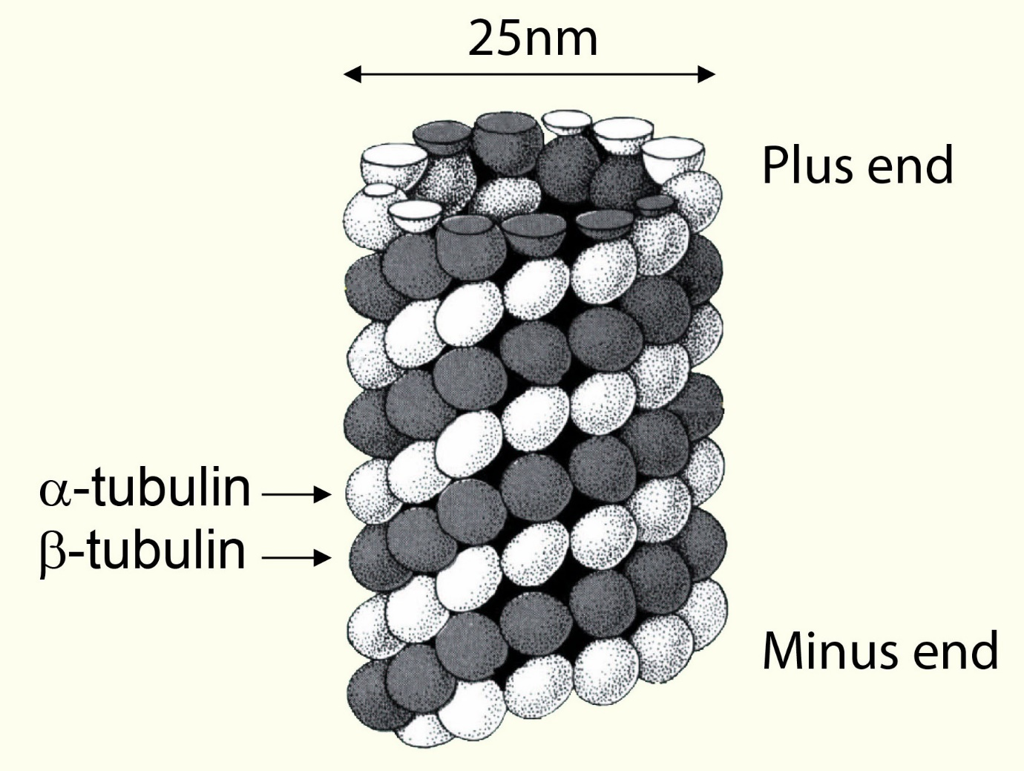
Fig:Structure of microtubulin

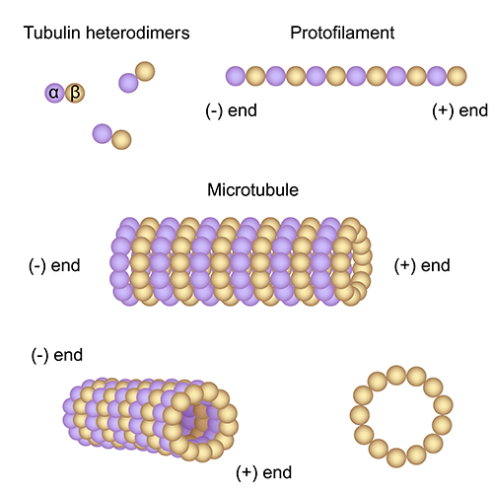
Assemble of microtubules

Assembly
- Microtubules undergo reversible assembly- disassembly (i.e., polymerization– depolymerization), depending on the need of the cell or organelles.
- Their polymerization is regulated by certain microtubule-associated proteins (MAPs).
- The assembly of microtubules involves preferential addition of subunits (αβ dimers) to one end of the tubule, called A end (or net assembly end); the other end of the tubule is called D end (or net disassembly end). Such an assembly involves the hydrolysis of GTP to GDP. Thus, the assembly of tubulin in the formation of microtubules is a specifically oriented and programmed process.
- Centrioles, basal bodies, and centromeres of chromosomes are the sites of orientation for this assembly. Calcium and calmodulin (an acidic protein having four Ca2+ binding sites) are some other regulating factors in the in
- vivo polymerization of tubulin

Main Functions of Microtubules Within the Cell
As part of the cytoskeleton of the cell, microtubules contribute to:
- Giving shape to cells and cellular membranes.
- Cell movement, which includes contraction in muscle cells and more.
- Transportation of specific organelles within the cell via microtubule "roadways" or "conveyor belts."
- Mitosis and meiosis: movement of chromosomes during cell division and creation of the mitotic spindle.

Microtubules, Cell Division and the Mitotic Spindle
Cell division is not only important to reproduce life, but to make new cells out of old. Microtubules play an important role in cell division by contributing to the formation of the mitotic spindle, which plays a part in the migration of duplicated chromosomes during anaphase. As a "macromolecular machine," the mitotic spindle separates replicated chromosomes to opposite sides when creating two daughter cells.
The polarity of microtubules, with the attached end being a minus and the floating end being a positive, makes it a critical and dynamic element for bipolar spindle grouping and purpose. The two poles of the spindle, made from microtubule structures, help to segregate and separate duplicated chromosomes reliably.

Microtubules Give Structure to Cilia and Flagellum
Microtubules also contribute to the parts of the cell that help it move and are structural elements of cilia, centrioles and flagella. The male sperm cell for example, has a long tail that helps it reach its desired destination, the female ovum. Called a flagellum (the plural is flagella), that long, thread-like tail extends from the exterior of the plasma membrane to power the cell's movement. Most cells – in cells that have them – generally have one to two flagella. When cilia exist on the cell, many of them spread along the full surface of the cell's outer plasma membrane.
The cilia on cells that line a female organism's Fallopian tubes, for example, help to move the ovum to its fateful meetup with the sperm cell on its journey to the uterus. The flagella and cilia of eukaryotic cells are not the same structurally as those found in prokaryotic cells. Built with the same with microtubules, biologists call the microtubule arrangement a "9 + 2 array" because a flagellum or cilium consists of nine microtubule pairs in a ring that encloses a microtubule duo in the center.
Microtubule functions require tubulin proteins, anchoring locations and coordinating centers for enzyme and other chemical activities within the cell. In cilia and flagella, tubulin contributes to the central structure of the microtubule, which includes contributions from other structures like dynein arms, nexin links and radial spokes. These elements allow communication between microtubules, holding them together in a way that's similar to how actin and myosin filaments move during muscle contraction.

Two Major Groups of Microtubule Motors
The bead-like construction of microtubules serves as a conveyor belt, track or highway to transport vesicles, organelles and other elements within the cell to the places they need to go. Microtubule motors in eukaryotic cells include kinesins, which move to the plus end of the microtubule – the end that grows – and dyneins that move to the opposite or minus end where the microtubule attaches to the plasma membrane.
As "motor" proteins, kinesins move organelles, mitochondria and vesicles along the microtubule filaments through the power of hydrolysis of the energy currency of the cell, adenosine triphosphate or ATP. The other motor protein, dynein, walks these structures in the opposite direction along microtubule filaments toward the minus end of the cell by converting the chemical energy stored in ATP. Both kinesins and dyneins are the protein motors used during cell division.
Recent studies show that when dynein proteins walk to the end of the minus side of the microtubule, they congregate there instead of falling off. They hop across the span to connect to another microtubule to form what some scientists call "asters," thought by scientists to be an important process in the formation of the mitotic spindle by morphing the multiple microtubules into a single configuration.
…………………………………………………………………………………………………………………………………………………………………

