Glycogenolysis definition

Glycogenolysis, process by which glycogen, the primary carbohydrate stored in the liver and muscle cells of animals, is broken down into glucose to provide immediate energy and to maintain blood glucose levels during fasting. Glycogenolysis occurs primarily in the liver and is stimulated by the hormones glucagon and epinephrine (adrenaline). When blood glucose levels fall, as during fasting, there is an increase in glucagon secretion from the pancreas. That increase is accompanied by a concomitant decrease in insulin secretion, because the actions of insulin, which are aimed at increasing the storage of glucose in the form of glycogen in cells, oppose the actions of glucagon. Following secretion, glucagon travels to the liver, where it stimulates glycogenolysis.

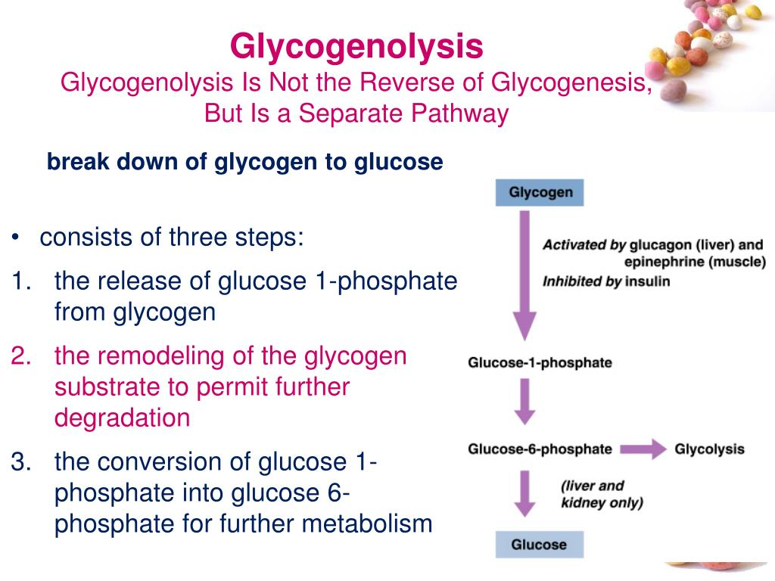

The vast majority of glucose that is released from glycogen comes from glucose-1-phosphate, which is formed when the enzyme glycogen phosphorylase catalyzes the breakdown of the glycogen polymer. In the liver, kidneys, and intestines, glucose-1-phosphate is converted (reversibly) to glucose-6-phosphate by the enzyme phosphoglucomutase. Those tissues also house the enzyme glucose-6-phosphatase, which converts glucose-6-phosphate into free glucose that is secreted into the blood, thereby restoring blood glucose levels to normal. Glucose-6-phosphate is also taken up by muscle cells, where it enters glycolysis (the set of reactions that breaks down glucose to capture and store energy in the form of adenosine triphosphate, or ATP). Small amounts of free glucose also are produced during glycogenolysis through the activity of glycogen debranching enzyme, which completes the breakdown of glycogen by accessing branching points in the polymer.
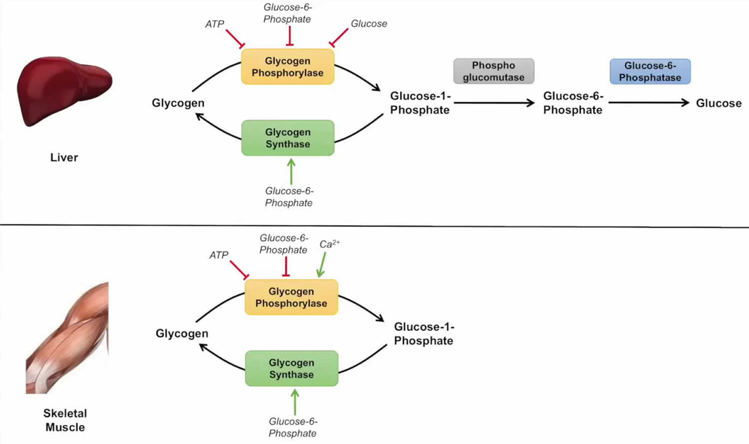
Glycogenolysis in liver and muscle.

Glycogenolysis steps
First step
The overall reaction for the 1st step is:
Glycogen (n residues) + Pi <—–> Glycogen (n-1 residues)+ glucose-1-phosphate
Here, glycogen phosphorylase cleaves the bond at the 1 position by substitution of a phosphoryl group. It breaks down glucose polymer at α-1-4 linkages until 4 linked glucoses are left on the branch.
Second step
The 2nd step involves the debranching enzyme that moves the remaining glucose units to another non-reducing end. This results in more glucose units available to glycogen phosphorylase (step 1)
Third step
The 3rd and last stage converts glucose-1-phosphate to glucose-6-phosphate through the enzyme phosphoglucomutase.

Glycogenolysis pathway
Glycogenolysis can occur via two pathways. Whereas the first pathway revolves around cytosolic degradation via the synchronized action of glycogen phosphorylase and glycogen debranching enzyme, the second pathway revolves around lysosomal degradation via the enzyme alfa glucosidase.

.

Corresponding to cytosolic degradation, glycogen phosphorylase, the rate-limiting enzyme of glycogenolysis, cleaves terminal glucose residue connected to a glycogen branch while substituting a phosphoryl group for the alpha 1-4 bond. Four residues before an alpha 1-6 bond, corresponding to a branch, glycogen debranching enzyme catalyzes the transfer of three of the four remaining glucose residues to the end of another glycogen chain, where they can again by degraded by glycogen phosphorylase. In other words, the breakage of alpha 1-4 glycosidic bonds present in linear chains is catalyzed by glycogen phosphorylase, and the addition of the phosphate group to position one results in the production of glucose-1-phosphate. The activity of glycogen phosphorylase is modulated allosterically and by phosphorylation. Glycogen production, conversely, inhibits glycogen degradation. Phosphoglucomutase is then in charge of converting glucose-1-phosphate to glucose-6-phosphate through an isomerization reaction that has no energy requirements. On the other hand, the debranching enzyme deals with alpha 1-6 bonds and transfers a branch to the end of the polymer so that glycogen phosphorylase can continue working with it. In most tissues, glucose-6-phosphate is internally utilized for glycolysis and energy production through conversion to pyruvate, acting as a critical metabolic intermediate for other pathways, including the citric acid cycle , fatty acid synthesis, Cori cycle, and alanine cycle. Nevertheless, in citric acid cycle, fatty acid synthesis, Cori cycle, and alanine cycle. Nevertheless, in gluconeogenic organs such as the liver, kidney, and intestines, glucose-6-phosphate needs to be dephosphorylated to glucose—with the aid of enzyme glucose-6-phosphatase— so that it can undergo transport from the endoplasmic reticulum to the interstitial space. Corresponding the lysosomal glycogen degradation, the primary enzyme involved in acid maltase. The hydrolysis of glycogen to glucose, catalyzed by acid alpha-glucosidase, has been hypothesized to serve a protective mechanism for the liver from high concentrations of glycogen. Of the total amount of glycogenolysis that happens in skeletal muscle, only 5% of glycogen degradation happens in lysosomes. For liver glycogenolysis, only 10% occurs in lysosome. ⁸Glycogenolysis clinical significance
The importance of glycogenolysis is demonstrated through mutations in glycogen degradation leading to human genetic disorders and through the inability of skeletal muscle to cope with physical stress when glycogen scarcity exists.
Dysfunctions in glycogenolysis can lead to a variety of diseases, including glycogen storage diseases, lysosomal storage diseases, and Lafora progressive myoclonus epilepsy. Disruptions in glycogenolysis frequently effectuate in dysfunction of organs, including the liver, skeletal muscle, brain, and kidney. Depending on the affected enzyme in glycogenolysis, a particular spectrum of syndromes is possible.
A disruption in glycogenolysis can result in glycogen storage diseases such as von Gierke disease, the most common glycogen storage disease. Type 1 glycogen storage disease is due to a deficiency in glucose-6-phosphatase, responsible for dephosphorylating glucose-6-phosphate so that glucose can get transported outside the cell for the regulation of blood glucose levels and fuel usage in other tissues outside of the liver. The impaired ability to generate glucose from glycogenolysis results in severe hypoglycemia,
Regulation of glycogenolysis:

Covalent modification by hormones: Norepinephrine and epinephrine (in liver and muscle) or glucagon in the liver only activate glycogen phosphorylase, while insulin inhibits it.

Allosteric regulation
- G-6-P and ATP inhibit glycogen phosphorylase because their elevated levels indicate that the cell isn’t in need of more energy and there is no need to breakdown glycogen.
- AMP stimulates glycogen phosphorylase in muscles.
- Calcium indirectly activates phosphorylase in muscle and liver.

