Glycogenesis definition

Glycogenesis is the process of glycogen synthesis, in which glucose molecules are added to chains of glycogen for storage. This process is activated during rest periods following the Cori cycle, in the liver, and also activated by insulin in response to high glucose levels.

Steps of Glycogenesis

- Glucose is converted into glucose 6-phosphate by the action of glucokinase or hexokinase with conversion of ATP to ADP.
- Glucose-6-phosphate is converted into glucose-1-phosphate by the action of phosphoglucomutase, passing through the obligatory intermediate glucose-1,6-bisphosphate.
- Glucose-1-phosphate is converted into UDP-glucose by the action of the enzyme UDP-glucose pyrophosphorylase. Pyrophosphate is formed, which is later hydrolysed by pyrophosphatase into two phosphate molecules.
- The enzyme glycogenin is needed to create initial short glycogen chains, which are then lengthened and branched by the other enzymes of glycogenesis. Glycogenin, a homodimer, has a tyrosine residue on each subunit that serves as the anchor for the reducing end of glycogen. Initially, about seven UDP-glucose molecules are added to each tyrosine residue by glycogenin, forming α(1→4) bonds.
- Once a chain of seven glucose monomers is formed, glycogen synthase binds to the growing glycogen chain and adds UDP-glucose to the 4-hydroxyl group of the glucosyl residue on the non-reducing end of the glycogen chain, forming more α(1→4) bonds in the process.
- Branches are made by glycogen branching enzyme (also known as amylo-α(1:4)→α(1:6)transglycosylase), which transfers the end of the chain onto an earlier part via α-1:6 glycosidic bond, forming branches, which further grow by addition of more α1:4 glycosidic units.

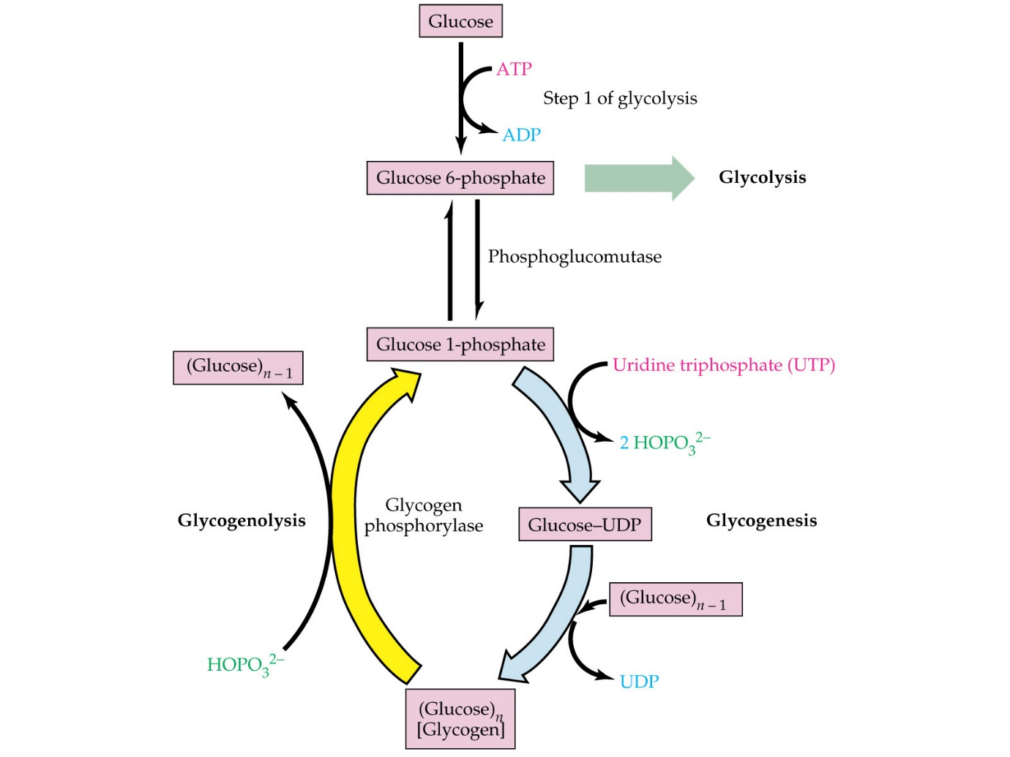

It is important for the cell to have an excess of glucose in order to commence the process of glycogenesis. Glucose is known to be the starting molecule that, via the glycogenesis process, is modified. The ability to be stored in long chains is imparted to the glucose through these changes. The process of glycogenesis is known to begin when a signal from the body to commence glycogenesis is received by the cell. It is important to note that these signals could come from a variety of different routes.
Initially, in the process of glycogenesis, the glucose molecule is known to interact with the glucokinase enzyme (which is an enzyme that adds to the glucose a group of phosphates). The phosphate group is moved to the other side of the molecule, with the help of the enzyme phosphoglucomutase, in the next step of the glycogenesis process. UDP-glucose pyrophosphorylase, which is another enzyme that is involved in this process, takes this molecule and produces glucose uracil-diphosphate. There are two phosphate groups in this glucose form, along with the nucleic acid uracil. Such additions help build a chain of molecules, which is vital for the next step of the glycogenesis process.
In the final stage of the glycogenesis process, a very important enzyme known as glycogenin plays a vital role. By attaching itself to this specific molecule, the UDP-diphosphate glucose tends to form relatively short chains. More enzymes facilitate the completion of the process after approximately 8 of these molecules form a chain together. This chain is then added to glycogen synthase. Simultaneously, the enzyme responsible for glycogen branching helps to build branches in the chains. This results in a fairly compact macromolecule that is quite efficient in storing energy.
Regulation of Glycogenesis

Via the process of phosphorylation, glycogen phosphorylase is known to be activated while glycogen synthase is known to be inhibited. Glycogen phosphorylase is generally transformed by the enzyme known as phosphorylase kinase from its relatively less reactive “b” form to a relatively more reactive “a” form. Phosphorylase kinase is also known to be activated by the protein kinase A. Furthermore, phosphoprotein phosphatase-1 is known to be deactivated by the same protein.
The hormone adrenaline acts to stimulate the protein kinase A. Furthermore, the hormone epinephrine binds itself to an adenylate cyclase-activating receptor protein. This enzyme also allows ATP to form cyclic AMP. Two cyclic AMP molecules tend to bind to the kinase A regulatory subunit, which activates it. This allows the protein kinase A catalytic subunit to dissociate from the assembly and to subject other proteins to phosphorylation.
Not only does epinephrine activate glycogen phosphorylase, it also contributes towards the inhibition of glycogen synthase. The effect of activating glycogen phosphorylase is amplified by this a similar mechanism accomplishes this inhibition.

