Gluconeogenesis

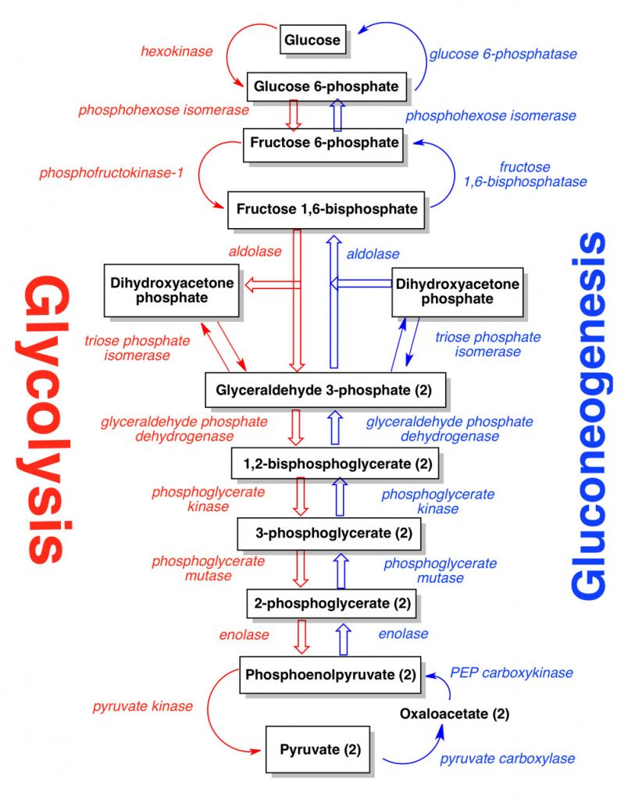
Fig: Gluconeogenesis
Gluconeogenesis is the metabolic process by which organisms produce sugars (namely glucose) for catabolic reactions from non-carbohydrate precursors. Glucose is the only energy source used by the brain (with the exception of ketone bodies during times of fasting), testes, erythrocytes, and kidney medulla. In mammals this process occurs in the liver and kidneys.

Introduction
The need for energy is important to sustain life. Organisms have evolved ways of producing substrates required for the catabolic reactions necessary to sustain life when desired substrates are unavailable. The main source of energy for eukaryotes is glucose. When glucose is unavailable, organisms are capable of metabolizing glucose from other non-carbohydrate precursors. The process that coverts pyruvate into glucose is called gluconeogenesis. Another way organisms derive glucose is from energy stores like glycogen and starch.
Steps of Gluconeogenesis

Gluconeogenesis is much like glycolysis only the process occurs in reverse. However, there are exceptions. In glycolysis there are three highly exergonic steps (steps 1,3,10). These are also regulatory steps which include the enzymes hexokinase, phosphofructokinase, and pyruvate kinase. Biological reactions can occur in both the forward and reverse direction. If the reaction occurs in the reverse direction the energy normally released in that reaction is now required. If gluconeogenesis were to simply occur in reverse the reaction would require too much energy to be profitable to that particular organism. In order to overcome this problem, nature has evolved three other enzymes to replace the glycolysis enzymes hexokinase, phosphofructokinase, and pyruvate kinase when going through the process of gluconeogenesis:
- The first step in gluconeogenesis is the conversion of pyruvate to phosphoenolpyruvic acid (PEP). In order to convert pyruvate to PEP there are several steps and several enzymes required. Pyruvate carboxylase, PEP carboxykinase and malate dehydrogenase are the three enzymes responsible for this conversion. Pyruvate carboxylase is found on the mitochondria and converts pyruvate into oxaloacetate. Because oxaloacetate cannot pass through the mitochondria membranes it must be first converted into malate by malate dehydrogenase. Malate can then cross the mitochondria membrane into the cytoplasm where it is then converted back into oxaloacetate with another malate dehydrogenase. Lastly, oxaloacetate is converted into PEP via PEP carboxykinase. The next several steps are exactly the same as glycolysis only the process is in reverse.
- The second step that differs from glycolysis is the conversion of fructose-1,6-bP to fructose-6-P with the use of the enzyme fructose-1,6-phosphatase. The conversion of fructose-6-P to glucose-6-P uses the same enzyme as glycolysis, phosphoglucoisomerase.
- The last step that differs from glycolysis is the conversion of glucose-6-P to glucose with the enzyme glucose-6-phosphatase. This enzyme is located in the endoplasmic reticulum.

Regulation
Because it is important for organisms to conserve energy, they have derived ways to regulate those metabolic pathways that require and release the most energy. In glycolysis and gluconeogenesis seven of the ten steps occur at or near equilibrium. In gluconeogenesis the conversion of pyruvate to PEP, the conversion of fructose-1,6-bP, and the conversion of glucose-6-P to glucose all occur very spontaneously which is why these processes are highly regulated. It is important for the organism to conserve as much energy as possible. When there is an excess of energy available, gluconeogenesis is inhibited. When energy is required, gluconeogenesis is activated.
- The conversion of pyruvate to PEP is regulated by acetyl-CoA. More specifically pyruvate carboxylase is activated by acetyl-CoA. Because acetyl-CoA is an important metabolite in the TCA cycle which produces a lot of energy, when concentrations of acetyl-CoA are high organisms use pyruvate carboxylase to channel pyruvate away from the TCA cycle. If the organism does not need more energy, then it is best to divert those metabolites towards storage or other necessary processes.
- The conversion of fructose-1,6-bP to fructose-6-P with the use of fructose-1,6-phosphatase is negatively regulated and inhibited by the molecules AMP and fructose-2,6-bP. These are reciprocal regulators to glycolysis' phosphofructokinase. Phosphofructosekinase is positively regulated by AMP and fructose-2,6-bP. Once again, when the energy levels produced are higher than needed, i.e. a large ATP to AMP ratio, the organism increases gluconeogenesis and decreases glycolysis. The opposite also applies when energy levels are lower than needed, i.e. a low ATP to AMP ratio, the organism increases glycolysis and decreases gluconeogenesis.
- The conversion of glucose-6-P to glucose with use of glucose-6-phosphatase is controlled by substrate level regulation. The metabolite responsible for this type of regulation is glucose-6-P. As levels of glucose-6-P increase, glucose-6-phosphatase increases activity and more glucose is produced. Thus glycolysis is unable to proceed.

