Chemiosmotic hypothesis:
Mitchell studied the mitochondrion, the organelle that produces energy for the cell. ATP is made within the mitochondrion by adding a phosphate group to ADP in a process known as oxidative phosphorylation. Mitchell was able to determine how the different enzymes involved in the conversion of ADP to ATP are distributed within the membranes that partition the interior of the mitochondrion. He showed how these enzymes’ arrangement facilitates their use of hydrogen ions as an energy source in the conversion of ADP to ATP.
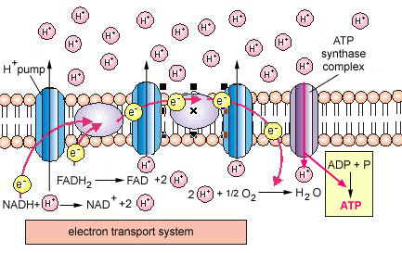  Chemiosmotic hypothesis: Proposed by Peter Mitchel (1970)  to explain how NADH oxidation is coupled to ATP synthesis. | As electrons are passed down the chain, protons are pumped across the membrane (between the inner membrane and outer membrane of the cristae or thylakoids). This results in a pH and electrical gradient. The protons move back into the matrix through a pore created by ATP synthetase allowing the enzyme to make ATP at the expense of this gradient.
Peter Mitchell’s 1961 paper introducing the chemiosmotic hypothesis started a revolution which has echoed beyond bioenergetics to all biology, and shaped our understanding of the fundamental mechanisms of biological energy conservation, ion and metabolite transport, bacterial motility, organelle structure and biosynthesis, membrane structure and function, homeostasis, the evolution of the eukaryote cell, and indeed every aspect of life in which these processes play a role. The Nobel Prize for Chemistry in 1978 was awarded to Peter Mitchell as the sole recipient.

