COLLOIDAL SOLUTIONS
Colloids or colloidal dispersion has traditionally been defined as a suspension of small particles in a continuous medium. The size of dispersed particles ranges from 1μm to 1nm.
Phases of Colloids:
A colloidal solution is heterogeneous in nature consisting of two phases:
- Dispersed phase: The extremely small particles which are dispersed in the solvent, form a dispersed phase. e.g. Colloidal solution of silver in water.
- Dispersion medium: The solvent in which the particles are dispersed forms a dispersion medium.
CLASSIFICATION OF COLLOIDS:
- Based upon appearance, colloids are classified into two types:
- Sol: If the appearance of the colloidal solution is like a fluid, it is called a sol.
Sols in which water is present as the dispersion medium are called hydrosols. Those
which contain benzene as the dispersion medium are called benzosols. If alcohol is a dispersion medium, it is called alcosol. e.g. paints, muddy water, etc.
- Gel: The colloidal solutions which have more rigid structures are called Gels. e.g. butter, jellies,etc.
Gelatin behaves both as sol and gel.
- Based on interaction of phases, colloids are classified into into types:
- Lyophilic colloids (solvent loving): The colloidal solutions in which particles of the dispersed phase have great affinity for the dispersion medium are called Lyophilic colloids. These are reversible. e.g. gums, starch, etc.
- Lyophobic colloids (solvent hating): The colloidal solutions in which particles of the dispersed phase have no affinity towards the dispersion medium are called lyophobic colloids. These sols are less stable and cannot be easily prepared. These can be easily prepared by heating the sol or on adding small amount of electrolyte to it. e.g. Fe(OH)₃
- Based upon type of particles of the dispersed phase, colloids are divided into three types:
- Multimolecular colloids: On dissolution, a large number of atoms or smaller molecules of a substance aggregate together to form species having size in the colloidal range (diameter<1nm). The species thus formed are called multimolecular colloids. e.g Sulphur sol consists of particles containing a thousand or more of S₈ sulphur molecules.
- Macromolecular colloids: Macromolecules (Unit 15) in suitable solvents form solutions in which the size of the macromolecules may be in the colloidal range. Such systems are called macromolecular colloids. These colloids are quite stable and resemble true solutions in many respects. Examples of naturally occurring macromolecules are starch, cellulose, proteins and enzymes; and those of man-made macromolecules are polythene, nylon, polystyrene, synthetic rubber, etc.
- Associated colloids (Micelles): There are some substances which at low concentrations behave as normal strong electrolytes, but at higher concentrations exhibit colloidal behaviour due to the formation of aggregates. The aggregated particles thus formed are called micelles. These are also known as associated colloids.
The formation of micelles takes place only above a particular temperature called Kraft temperature (T_{k}) and above a particular concentration called critical micelle concentration (CMC). These colloids have both lyophobic and lyophilic parts.
PREPARATION OF COLLOIDAL SOLUTIONS:
- Dispersion methods: The methods which involve the breakage of coarse particles into colloidal dimensions are called dispersion methods.
- Bredig’s arc method: In this method, metal electrodes are immersed in the dispersion medium which is further placed in the freezing mixture. When an electric arc is struck, an intense heat of the arc turns the metal into the vapours which get condensed by the ice cold water to give particles of colloidal size as desired. To stabilize the sol, a little KOH is added to the dispersion medium. The solution is then filtered to remove bigger particles. Metals like Pt, Ag, Cu, etc. are converted into their colloidal solution by this method.

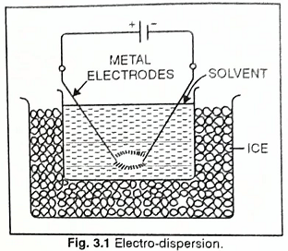

- Peptisation: Peptization may be defined as the process of converting a precipitate into colloidal sol by shaking it with dispersion medium in the presence of a small amount of electrolyte. The electrolyte used for this purpose is called peptizing agent. This method is applied, generally, to convert a freshly prepared precipitate into a colloidal sol. During peptization, the precipitate adsorbs one of the ions of the electrolyte on its surface. This causes the development of positive or negative charge on precipitates, which ultimately break up into smaller particles of the size of a colloid.
- Condensation or aggregation methods or chemical methods:
- Lowering of stability by exchange of solvent: In this method, a substance is dissolved in a solvent and then the solution is added to another solvent in which it is less soluble, a colloidal solution results. e.g. if an alcoholic solution of sulphur is added in excess of water, a colloidal solution of sulphur results.
- Chemical action: Colloidal solutions can be prepared by chemical reactions leading to formation of molecules by double decomposition, oxidation, reduction or hydrolysis. These molecules then aggregate leading to formation of sols.
decompostion
As₂O₃ + 3H₂S Double As₂S₃ (sol) + 3H₂O
Oxidation
SO₂ + 2H₂S 3S(sol) + 2H₂O
Reduction

2 AuCl₃ + 3 HCHO + 3H₂O 2Au (sol) + 3HCOOH + 6HCl
Hydrolysis
FeCl₃ + 3H₂O Fe(OH)₃
Purification of colloids:
The process used for reducing the amount of impurities to a requisite minimum is known as purification of colloidal solution.
- Dialysis: Dialysis is a process of removing a dissolved substance from a colloidal solution by means of diffusion through a suitable membrane. The apparatus used for this purpose is called dialyser.
- Graham’s dialysis: Graham’s dialyser consists of shallow cylinder open at both the ends. A bag of suitable membrane (such as parchment paper, bladder, cellophane sheet) containing the colloidal solution is suspended in the cylinder through which fresh water is continuously flowing. The molecules and ions diffuse through this membrane into the outer water and pure colloidal solution is left behind.
- Electro-dialysis: The process of dialysis can be made faster when carried under the influence of electric field. In this method, the outer vessel is fitted with two electrodes. The impure colloidal solution is taken in the shallow cylinder. The application of electric filed increases the movement of the ions to the oppositely charged electrode.
Limitation: This method is not suitable for the fast removal of molecular particles of sugar and other non-electrolytes from the colloidal solution.
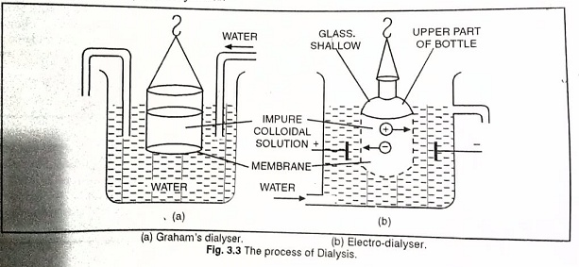

- Ultrafiltration: Ultrafiltration is the process of separating the colloidal particles from the solvent and soluble solutes present in the colloidal solution by specially prepared filters, which are permeable to all substances except the colloidal particles. Colloidal particles can pass through ordinary filter paper because the pores are too large. However, the pores of filter paper can be reduced in size by impregnating with collodion solution to stop the flow of colloidal particles. The usual collodion is a 4% solution of nitrocellulose in a mixture of alcohol and ether.
An ultra-filter paper may be prepared by soaking the filter paper in a collodion solution, hardening by formaldehyde and then finally drying it. Thus, by using ultra-filter paper, the colloidal particles are separated from rest of the materials. Ultrafiltration is a slow process. To speed up the process, pressure or suction is applied. The colloidal particles left on the ultra-filter paper are then stirred with fresh dispersion medium (solvent) to get a pure colloidal solution.
PROPERTIES OF COLLOIDAL SOLUTIONS:
- Heterogeneity: A colloidal solution is heterogeneous and consists of two phases, i.e. the colloidal particles and the dispersion medium.
- Osmotic pressure (colligative property): colloidal solutions exert less osmotic pressure.
- Brownian movement: When colloidal solutions are viewed under a powerful ultramicroscope, the colloidal particles appear to be in a state of continuous zig-zag motion all over the field of view. This motion was first observed by the British botanist, Robert Brown, and is known as Brownian movement. The Brownian movement has been explained to be due to the unbalanced bombardment of the particles by the molecules of the dispersion medium. The Brownian movement has a stirring effect which does not permit the particles to settle.
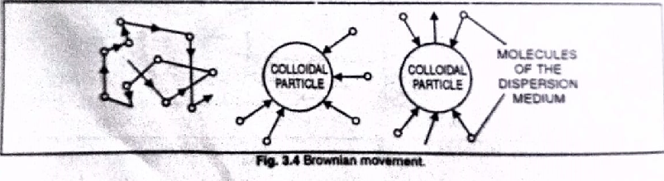
- Tyndall effect: When a strong beam of light is made to fall on a colloidal solution, the path of the beam is illuminated by a bluish light. This luminosity by the path of beam is known as Tyndall effect. It is due to the scattering of light on the surface of the colloidal particles. In this phenomenon, the particles become self-luminous due to the absorption of light energy and then scatter light of shorter wavelength.
In case, a convergent beam of light is made to fall upon a solution by means of a lens, a bright blue cone is observed. It is called Tyndall cone.

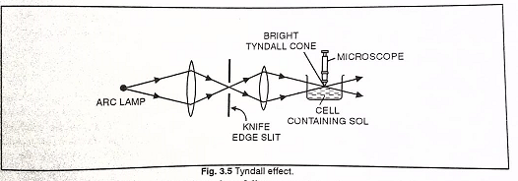
- Electrophoresis: Colloidal particles in a solution carry either positive or negative charge. Colloidal solutions in which solid particles carry positive charge are called positive sols. e.g. Sols of ferric hydroxide, methylene blue, etc. Colloidal solutions in which solid particles carry negative charge are called negative sols. e.g. Gums, starch, etc.
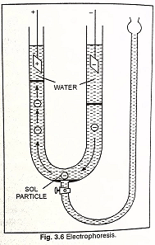

The existence of charge on colloidal particles is confirmed by electrophoresis experiment. When electric potential is applied across two platinum electrodes dipping in a colloidal solution, the colloidal particles move towards one or the other electrode. The movement of colloidal particles under an applied electric potential is called electrophoresis or cataphoresis. Positively charged particles move towards the cathode while negatively charged particles move towards the anode.
When electrophoresis, i.e., movement of particles is prevented by some suitable means, it is observed that the dispersion medium begins to move in an electric field. This phenomenon is termed electroosmosis.
ORIGIN OF CHARGE ON COLLOIDAL PARTICLES:
Sols are often associated with small quantities of electrolytes. The charge on the sol particles is due to one or more reasons, viz., due to electron capture by sol particles during electrodispersion of metals, due to preferential adsorption of ions from solution and/or due to formulation of electrical double layer. If the electrolytes are completely removed from the colloidal solution by repeated dialysis or ultrafiltration, then the sol becomes unstable. Thus, the charge on the colloidal particles is due to the preferential adsorption of either positive or negative ions on their surfaces. If the positive ions get absorbed, the sol particles acquire a positive charge.
COAGULATION OR PRECIPITATION:
The process of settling of colloidal particles is called coagulation or precipitation of the sol. The coagulation of the lyophobic sols can be carried out in the following ways:
- By electrophoresis: The colloidal particles move towards oppositely charged electrodes, get discharged and precipitated.
- By mixing two oppositely charged sols: Oppositely charged sols when mixed in almost equal proportions, neutralise their charges and get partially or completely precipitated. This type of coagulation is called mutual coagulation.
- By boiling: When a sol is boiled, the adsorbed layer is disturbed due to increased collisions with the molecules of dispersion medium. This reduces the charge on the particles and ultimately lead to settling down in the form of a precipitate.
- By persistent dialysis: On prolonged dialysis, traces of the electrolyte present in the sol are removed almost completely and the colloids become unstable and ultimately coagulate.
- By addition of electrolytes: When excess of an electrolyte is added, the colloidal particles are precipitated. The reason is that colloids interact with ions carrying charge opposite to that present on themselves. This causes neutralisation leading to their coagulation. The ion responsible for neutralisation of charge on the particles is called the coagulating ion. A negative ion causes the precipitation of positively charged sol and vice versa.
HARDY-SCHULZE RULE:
According to this rule, the higher the valency of the flocculating ion added, the greater is its power to cause precipitation.
In the coagulation of negatively charged sol, the flocculating power decreases in the order,
M³⁺> M²⁺ > M⁺
Similarly in the coagulation of the positively charged sol, the flocculating power decreases in the order: A³⁻ > A²⁻> A⁻.
STRUCTURE ZETA POTENTIAL:
A charged colloidal particle is surrounded by the ions of opposite charge. The combination of the two layers of opposite charges around the colloidal particle is called Helmholtz electrical double layer. The first layer of ions is firmly held and is termed fixed layer while the second layer is mobile which is termed diffused layer. Since separation of charge is a seat of potential, the charges of opposite signs on the fixed and diffused parts of the double layer results in a difference in potential between these layers. This potential difference between the fixed layer and the diffused layer of opposite charges is called the electrokinetic potential or zeta potential.

STABILITY OF COLLOIDS:
Hydrophobic sols are stabilized by the presence of like charges on colloidal particles. Due to the presence of like charges, colloidal particles repel each other and move away from each other and thus do not form bigger aggregates.
Solubility of lyophilic colloids is due to two reasons. Their particles possess a charge and in addition they are heavily solvated and the solvent layer surrounding them prevents them to come into intimate contact with each other. Hence, their coagulation is prevented.
PROTECTION OF COLLOIDS:
The property of the lyophilic colloids to prevent the precipitation of lyophobic colloids by electrolytes is called protection. Lyophilic sols are more stable than lyophobic sols. This is due to the fact that lyophilic colloids are extensively solvated, i.e., colloidal particles are covered by a sheath of the liquid in which they are dispersed. Lyophilic colloids have a unique property of protecting lyophobic colloids. When a lyophilic sol is added to the lyophobic sol, the lyophilic particles form a layer around lyophobic particles and thus protect the latter from electrolytes. Lyophilic colloids used for this purpose are called protective colloids.
GOLD NUMBER:
The number of milligrams of a hydrophilic colloid which just prevents the precipitation of 10 ml of a gold sol on the addition of 1 ml of ten percent sodium chloride solution is called gold number. e.g. Gold number of gelatin is 0.005-0.01.
SURFACTANTS:
These are defined as substances which get preferentially adsorbed at the air-water, oil-water and solid-water interfaces, forming an oriented monolayer in which hydrophilic groups point towards the aqueous phase and the hydrocarbon chains point towards the air or towards the oil phase. the surfactants can be cationic, anionic or non-ionogenic.
e.g. Sodium stearate = anionic surfactant
Octa cetyl ammonium chloride =cationic surfactant

Home assignments:
- Explain five applications of colloids. (5)
- Write about the mechanism of micelle formation. (5)
- Distinguish between lyophilic and lyophobic sols. (5)
- Explain the cleansing action of soap. (5)

